OCEAN WALK

Ocean walk, L.L.C.
520 Ocean Boulevard, Suite 218 • St. Simons Island, Georgia 31522
912-638-5450 • 1-888-ST.SIMONS • FAX 912-638-2983
DECLARATION
OF CONDOMINIUM

for
OCEAN WALK, A CONDOMINIUM

THIS INSTRUMENT PREPARED BY AND AFTER RECORDING RETURN TO :
LEE & MACMILLAN, P.A. 300 MAIN STREET
SUITE 201,
ST. SIMONS ISLAND, GEORGIA 31522
DECLARATION OF CONDOMINIUM for
OCEAN WALK, A CONDOMINIUM
Exhibit Matter
Legal Description of Submitted Property
Matters Affecting Title c Description of Boundaries of Units
D Description of Limited Common Elements
Schedule of Units and the Voting Rights and
Assessments Allocated to Each
Bylaws of the Association
STATE OF GEORGIA
COUNTY OF GLYNN
DECLARATION OF CONDOMINIUM for
OCEAN WALK, A CONDOMINIUM
THIS DECLARATION is made by Ocean Walk, LLC, a Georgia limited liability company (hereinafter called the "Declarant") .

W I T N E S S E T H
WHEREAS, Declarant is the fee simple owner of that certain tract or parcel of land lying and being on St. Simons Island, in Glynn County, Georgia, as more particularly described in Exhibit "A" attached hereto and i.ncorporated herein by reference, hereinafter called the "Property" subject to the matters set forth on Exhibit "B" attached hereto; and
WHEREAS, certain improvements have been constructed on the Property as shown on the Plat and the Plans which are referenced in Section 5.01 (a) and (b) hereof; and
WHEREAS , Declarant has duly incorporated Ocean Walk Condominium Association, Inc. as a nonprofit membership corporation under the laws of the State of Georgia; and
WHEREAS, the Declarant desires to submit the Property to the condominium form of ownership pursuant to the provisions of the Georgia Condominium Act, as the same is in effect on the date hereof (O. C. G. A. Section 44—3—70 through Section 44—3—116, as amended, hereinafter called the "Act , the terms, conditions and provisions of which are incorporated herein by express reference, and the terms and conditions hereinafter set out.
NOW, THEREFORE, the Declarant does hereby make, declare and publish its intention and desire to submit, and does hereby submit, the Property to the condominium form of ownership pursuant to, subject to and in accordance with the provisions of the Act and the terms and conditions hereinafter set forth.
ARTICLE 1
1 . 01 -The name of the condominium shall be OCEAN WALK, CONDOMINIUM (the "Condominium") .
ARTICLE 11

DESCRIPTION OF SUBMITTED PROPERTY
2.01-The Property is located on St. Simons Island in Glynn County, Georgia, and is more particularly described in Exhibit "A" attached hereto and incorporazed herein by reference.
2 . 02-The Property is subj ect to the easements and other matters which are set forth on Exhibit "B" attached hereto and by reference made a part hereof.
2 . 03-The Condominium is not expandable and contains no convertible space.
ARTICLE 111

DEFINITIONS
3.01 —Generally, terms used in this Declaration, the Bylaws, and the Articles of Incorporation shall have their normal, generally accepted meanings or the meanings given in the Act or the Georgia Nonprofit Corporation Code. Unless the context otherwise requires, certain terms used in this Declaration, the Bylaws, and the Articles of Incorporation shall be defined as follows:
- shall mean the Georgia Condominium Act, O. C. G. A. S 44-3—70, s.eg. (Michie 1982) , as such act may be amended from time to time .
- Architectural Control Committee or ACC shall mean the committee established to exercise the architectural review powers set forth in Article X Il hereof.
- Area of Common Responsibility shall mean and refer to the Conunon Elements, together with those areas, If any, which by the terms of this Declaration or by contract or agreement with any other person or entity become the responsibility of the Association .
- Articles or Articles of Incorporation shall mean the Articles of Incorporation of Ocean Walk Condominium Association, Inc. , which have been filed with the Secretary of State of the State of Georgia.
- Association shall mean Ocean Walk Condominium
Association, Inc. , a Georgia nonprofit corporation, its successors or assigns.
- Balcony shall mean Limited Common Elements located appurtenant to second floor Units.
- Board or Board of Directors shall mean the elected body responsible for management and operation of the Association.
- Bylaws shall mean the Bylaws of Ocean Walk Condominium Association, Inc. , attached to this Declaration as Exhibit "F" and incorporated herein by this reference.
- Common Elements shall mean those portions of the Property subject to this Declaration which are not included within the boundaries of a Unit, as more particularly described in this Declaration.
(j ) Common Expenses shall mean the expenses incurred or anticipated to be incurred by the Association for the general benefit of the Condominium, including, but not limited to, those expenses incurred for maintaining, repairing, replacing, and operating the Corunon Elements .
(k) Community-Wide Standard shall mean the standard of conduct, maintenance, or other activity generally prevailing within the Condominium. Such standard may be more specifically determined by the Board of Directors and the Architectural Control Cornmittee.
(1) Condominium shall mean all that real property described in Exhibit "A" attached hereto and incorporated herein by this reference, submitted to the provisions of the Act by this Declaration.
- Condominium Instruments shall mean this Declaration and all exhibits to this Declaration, including the Bylaws of the Association, and the plats and plans, all as may be supplemented or amended from time to time .
- Declarant shall mean Ocean Walk, L. L.C. , a Georgia limited liability company, its respective successors and assigns.
- Eligible Mortgage Holder shall mean those holders of first mortgages secured by Units in the Condominium who have requested notice of certain items as set forth in this Declaration.
- Floor Plans shall mean the floor plans for Ocean Walk Condominium, filed in the condominium file cabinet of the Glynn County, Georgia records.
- Limited Common Elements shall mean a portion of the Common Elements reserved for the exclusive use of those entitled to occupy one (1) or more, but less than all, Units, as more particularly set forth in this Declaration.
- Majority means those eligible votes, Owners, or other group as the context may indicate totaling more than fifty (50%) percent of the total eligible number.
- Mortgage shall refer to any mortgage, deed to secure debt, deed of trust, or other transfer or conveyance for the purpose of securing the performance of an obligation, including, but not limited to, a transfer or conveyance of fee title for such purpose .
- Mortgagee or Mortgage Holder shall mean the holder of any mortgage .
- Occupant shall mean any Person occupying all or any portion of a Unit for any period of time, regardless of whether such Person is a tenant or the Owner of such property.
- Owner shall mean the record title holder of a Unit within the Condominium, but shall not include a Person who is only a Mortgage Holder.
- Rex-son shall mean any individual, corporation, firm, association, partnership, trust, or other legal entity.
- Survey shall mean the plat of survey for Ocean Walk, A Condominium, filed in the condominium plat book of the Glynn County, Georgia records.
(Y) R.e.z.a.ge shall mean Limited Common Elements located appurtenant to the first floor Units.
(z) Unit shall mean that portion of the Condominium intended for individual ownership and use as more particularly described in this Declaration and shall include the undivided ownership in the Common Elements assigned to the Unit by this Declaration.
ARTICLE IV

PLAT PLANS
4 . 01 —Simultaneously with the recording of this Declaration with the Clerk of Superior Court of Glynn County, Georgia, the Plat and Plans will also be recorded and the Plat and Plans are incorporated herein by this reference as if the same were fully set forth entirely herein. So long as Declarant owns a Unit, Declarant reserves the right, but shall have no obligation, to make improvements and changes to all or part of the Common Elements and the Units owned by Declarant (other than changes to the location of Unit boundaries unless expressly permitted herein) , including, without limitation, addition and realignment of parking spaces, renovation and installation of changes to the utility systems and facilities, rearrangement and installation of security and refuse facilities, work relating to building exteriors, and extension of the drives and utility lines and pipes located on the Condominium.
ARTICLE V
INFOnmTION AND BOUNDARIES
5.01-The buildings and structures situated upon the property are:
- located thereon as shown on that certain plat of Ocean Walk, A Condominium, dated April 29, 1997 and last revised on September 13, 1998, prepared by Freeman & Vaughn Engineering, Inc. bearing the seal and certification of Michael A. Hussey, Georgia Registered Land Surveyor No. 2059, which plat has been prepared in accordance with Official Code of Georgia Annotated Section 44-3-83 to be filed in the Condominium Plat Book in Glynn County, Georgia Records (hereinafter said condominium plat as recorded is referred to as the "Plat" or the "Condominium Plat") ;
- divided into two hundred thirty two (232) residential units intended for independent ownership and use and as substantially shown upon those certain Plans for Ocean Walk, dated October 7, 1998, prepared by Ussery-Ru1e Architects, P.C. , to be filed in the Condominium Floor Plans Cabinet, Glynn County, Georgia Records (hereinafter said plans are referred to as the "Plans" or the "Condominium Plans") .
5.02-Unit Number. Each Unit shall have the identifying number allocated to it in accordance with the Plat and the Plans.
5. 03—Boundaries. The boundaries of the Units are the floors, ceilings and walls delineated on the Plans and as described in Exhibit "C" attached hereto and by reference made a part hereof. If any chute, flue, duct, conduit, wire, bearing wall, bearing column or any other apparatus lies partially within and partially outside the designated boundaries of a Unit, any portions thereof serving only that unit shall be deemed a part of that Unit, and any portions thereof serving more than one Unit or any portion of the Cortunon Elements shall be deemed a part of the Conunon Elements .
5 . 04—Subdivision and Partition of Uni ts; Relocation of Boundaries. Subject to the provisions of Official Code of Georgia Annotated Section 44—3-91 and the By—Laws of the Association, the boundaries between adjoining Units may be relocated from time to time, but no Unit may be subdivided for the purpose of creating two or more Units therefrom and no owner shall have the right of partition of a Unit.
ARTICLE VI

LIMITED COMMON ELEMENTS
- 01 —Generally. The Limited Common Elements are those portions of the Common Elements which are reserved for the exclusive use of those persons who are entitled to the use of any Unit or Units to which such Common Elements are assigned. The Limited Common Elements r and the Units to which they are assigned, are described on Exhibit "D" attached hereto and by reference made a part hereof.
6.02 Other Limi ted Common Elements. Any shutter, awning, window box, doorstep, and other apparatus described in Official Code of Georgia Annotated Section 44—3—75 (a) (5) designed to serve a single Unit shall be deemed to be a Limited Common Element appertaining to that unit exclusively.
ARTICLE Vil

ALLOCATION OF UNDIVIDED INTEREST IN THE COhnv10N ELEMENTS
7.01 The undivided interest in the Common Elements allocated to each Unit is set forth on Exhibit "E" attached hereto and incorporated herein by reference.
ARTICLE Vill

ASSOCIATION MEMBERSHIP AND ALLOCATION OF VOTES IN THE ASSOCIATION
8.01 All Unit Owners, by virtue of their ownership of a fee or undivided fee interest in any Unit in the Condominium, excluding Persons holding such interest under a Mortgage, are members of Ocean Walk Condominium Association, Inc. , and, except as otherwise provided herein or in the Bylaws, shall be entitled to vote on all matters upon which members of the Association are entitled to vote pursuant to the Declaration and in accordance with the Bylaws. Subj ect to the provisions of the Condominium Instruments, each Owner shall be entitled to one (1) equally weighted vote.
ARTICLE IX

ALLOCATION OF LIABILITY FOR coh.N0N EXPENSES
9. 01—Assessments . Except as provided below, or elsewhere in the Act or Condominium Instruments, the amount of all Common Expenses shall be assessed against all the Units in accordance with the percentage of undivided interest in the Common Elements appurtenant to the Unit as shown on Exhibit "E. "
9.02-Specia1 Assessments. The Board of Directors shall have the power to assess specially pursuant to this Section and to Section 44—3—80 (b) of the Act as, in its discretion, it shall deem appropriate . Failure of the Board of Directors to exercise its authority under this Section shall not be grounds for any action against the Association or the Board of Directors and shall not constitute a waiver of the Board's right to exercise its authority under this Section in the future with respect to any expenses, including an expense for which the Board has not previously exercised its authority under this Section.
- Any Comxnon Expenses benefiting less than all of the Units or significantly disproportionately benefiting all Units may be specially assessed equitably among all of the Units which are benefited according to the benefit received. However, expenses incurred for the maintenance, repair, or replacement of the Area of Common Responsibility, shall not be specially assessed.
- Any Common Expenses occasioned by the conduct of less than all of those entitled to occupy all of the Units or by the Occupant (s) , licensees or invitees of any such Unit or Units may be specially assessed against such Unit or Units.
9.03-Water Meters. The Condominium currently is served by a cornmon water meter. The Board shall have the authority to install submeters and assess individual Unit utilities usage charges, including a right to add a charge for the cost of overhead for such submetering, against individual Units and/or to install separate utility meters for the Units.
ARTICLE X
ASSOCXATION RIGHTS RESTRICTIONS
10 . 01 -Rights of Association. In addition to and not in limitation of all other rights it may have, the Association, acting through its Board of Directors, shall have the right and authority:
- to enter into Units for maintenance, emergency, security, or safety purposes, which right may be exercised by the Association's Board of Directors, officers, agents, employees, managers, and all police officers, firemen, ambulance personnel, and similar emergency personnel in the performance of their respective duties. Except in an emergency situation, entry shall be only during reasonable hours and after reasonable notice to the Owner or Occupant of the Unit;
- to make and to enforce reasonable rules and regulations governing the use of the Condominium, including the Units, Limited Common Elements, and Common Elements ;
- to enforce use restrictions, other Declaration and Bylaws provisions, and rules and regulations by the imposition of reasonable monetary fines and suspension of use and voting privileges as provided in Section 44—3—76 of the Act, as amended;
- to grant permits, licenses, utility easements, and other easements;
- to control, manage, operate, maintain, improve and replace all portions of the Area of Common Responsibility;
- to deal with the Condominium in the event of damage or destruction as a result of casualty loss, condemnation or eminent domain, in accordance with the provisions of the Act and this Declaration ;
- to acquire, hold, and dispose of tangible and intangible personal property and real property; and
- to close permanently or temporarily any portion of the
Corrunon Elements (excluding the Limited Common Elements) with thirty (30) days prior notice to all Owners, except that, in emergency situations requiring a temporary closing, prior notice shall not be required so long as notice is given within three (3) days after the closing explaining the reason for the closing. Notwithstanding the above, the Owners may re-open closed Common Elements by a majority vote of the total Association vote, cast at a duly called special or annual meeting.
- to establish a construction deposit in a reasonable amount determined by the Board of Directors to be paid by all Owners making modifications, alterations or additions to their Units in order to protect the Condominium against damage due to the transportation and use of construction materials in the Condominium. Costs for repair of such damage may be deductible from the construction deposit and any additional expenses may be specifically assessed against the Unit under Section 9.02 (b) above.
ARTICLE Xl
ASSESS2GN%'S
11. 01 —Purpose of Assessment. The Association shall have the power to levy assessments as provided herein and in the Act. The assessments for Common Expenses provided for herein shall be used for the general purposes of promoting the recreation, health, safety, welfare, common benefit, and enjoyment of the Owners and Occupants of Units in the Condominium as may be more specifically authorized from time to time by the Board.
11.02-Crea t ion of the Lien and Personal Obliga t ion For Assessmen ts . Each Owner of any Unit, by acceptance of a deed therefor, whether or not it shall be so expressed in such deed, is deemed to covenant and agree to pay to the Association: (i) annual assessments or charges; (i i) special assessments, such assessments to be established and collected as hereinafter provided; and (i i i) specific assessments against any particular Unit which are established pursuant to the terms of this Declaration, including but not limited to reasonable fines imposed in accordance with the terms of this Declaration.
All such assessments, together with charges, interest, costs, and reasonable attorney's fees actually incurred, and if the Board so elects, rents, in the maximum amount permitted by the Act, shall be a charge on the Unit and shall be a continuing lien upon the Unit against which each assessment is made. Such amounts shall also be the personal obligation of the Person who was the Owner of such Unit at the time when the assessment fell due. Each Owner and his or her grantee shall be jointly and severally liable for all assessments and charges due and payable at the time of any conveyance .
Assessments shall be paid in such manner and on such dates as may be fixed by the Board of Directors; unless otherwise provided, the annual assessments shall be paid in equal monthly installments due on the first day of each calendar month. No Owner may exempt himself or herself from liability for or otherwise withhold payment of assessments for any reason whatsoever, including, but not limited to, nonuse of the Common Elements, the Association' s failure to perform its obligations required hereunder, or inconvenience or discomfort arising from the Association' s performance of its duties. The lien provided for herein shall have priority as provided in the Act.
11.03-De1inquent Assessments. All assessments and related charges not paid on or before the due date shall be delinquent, and the Owner shall be in default.
- If any monthly installment of annual assessments or any part thereof is not paid in full by the tenth (10th) day of the month or if any other charge is not paid within ten (10) days of the due date, a late charge equal to the greater of ten ($10.00) dollars or ten (10%) percent of the amount not paid, or such higher amounts as may be authorized by the Act, may be imposed without further notice or warning to the delinquent Owner and interest at the rate of ten (10%) percent per annum or such higher rate as may be permitted by the Act shall accrue from the due date.
- If part payment of assessments and related charges is made, the amount received may be applied first to costs and attorney's fees, then to late charges, then to interest, then to delinquent assessments, and then to current assessments.
- If assessments, fines or other charges or any part thereof due from an Owner remain delinquent and unpaid for a period greater than fifteen (15) days from the date due, a notice of delinquency may be given to that Owner stating that if the assessment, fine or charge remains delinquent for more than ten (10) days from the date of the notice of delinquency, the Board of Directors may accelerate and declare imrnediately due all of that Owner's unpaid installments of the annual assessment and of any special assessment . If an Owner fails to pay all assessments and related charges currently due within ten (10) days of the date of the notice of delinquency, the Board of Directors may then accelerate and declare immediately due all installments of the annual assessment and of any special assessment, without any further notice being given to the delinquent Owner. Upon acceleration, that Owner shall thereby lose the privilege of paying the annual assessment in monthly installments for that fiscal year.
- If assessments and other charges or any part thereof remain unpaid more than thirty (30) days after the assessment payments first become delinquent, the Association, acting through the Board of Directors, may institute suit to collect all amounts due pursuant to the provisions of the Declaration, the Bylaws, the Act and Georgia law and suspend the Owner's and/or Occupant! s right to vote and the right to use the Common Elements; provided, however, the Board may not limit ingress or egress. Enforcement under this subsection is not dependent upon or related to other restrictions and/or other actions.
If any assessment or other charge is delinquent for thirty (30) days or more, in addition to all other rights provided in the Act and herein, the Association shall have the right upon ten (10) days written notice, and in compliance with any requirements set forth in the Act, to suspend any utility or service, the cost of which are an Association Common Expense, including, but not limited to, water, electricity, heat, air conditioning and cable television, to that Unit until such time as the delinquent assessments and all costs permitted under this Section, including reasonable attorney's fees, are paid in full. Any costs incurred by the Association in discontinuing and/or reconnecting any utility service, including reasonable attorney's fees, shall be an assessment against the Unit.
Notwithstanding the above, the Board only may suspend any utility or service, including cable television, paid for as a Common Expense after a final judgment or judgments in excess of a total of $750. 00, or such other amount as required by the Act, are obtained in favor of the Association from a court of competent jurisdiction, the Association provides the notice required to be provided by the institutional provider of such service prior to suspension of such service, and the Association complies with any other requirements of O. C. G. A. S 44-3-76. The utility services shall not be required to be restored until all judgments are paid in full, at which time the Association shall direct the utility provider to restore the service.
11.04—Computation of Opera ting Budget and Assessment. It shall be the duty of the Board at least twenty-one (21) days prior to the beginning of the Association's fiscal year to prepare a budget covering the estimated costs of operating the Condominium during the coming year. The Board shall cause the budget and notice of the assessments to be levied against each Unit for the following year to be delivered to each member at least thirty (30) days prior to the Association's annual meeting. The budget and the assessment shall become effective unless disapproved at a duly called and constituted annual meeting of the Association by a vote of a majority of the total Association vote; provided, however, if a quorum is not obtained at the annual meeting, the budget shall become effective even though a vote to disapprove the budget could not be called at this meeting.
Notwithstanding the foregoing, in the event that the membership disapproves the proposed budget or the Board fails for any reason so to determine the budget for the succeeding year, then and until such time as a budget shall have been determined as provided herein, the budget in effect for the current year shall continue for the succeeding year . In such case, the Board may propose a new budget at any time during the year at a special meeting of the Association. The proposed budget and assessment shall be delivered to the members at least thirty (30) days prior to the proposed effective date thereof and at least seven (7) days prior to the special meeting. The approval procedure set forth above for budgets considered at annual meetings shall also apply to budgets considered at special meetings .
Enforcement under this Section is not dependent upon or related to other restrictions and/or other actions .
11. 05-Specia1 Assessments. In addition to the annual assessment provided for in Section 11.02 above, the Board may, at any time, and in addition to any other rights it may have, levy a special assessment against all Owners, notice of which shall be sent to all Owners. Any special assessment (except as provided in Section 9.02 regarding the power to assess specially pursuant to Section 44-3-80 (b) of the Act and Section 14.07 herein, regarding repair or reconstruction of casualty damage to or destruction of all or part of the Condominium) which would cause the average total of special assessments levied in one fiscal year to exceed two hundred ($200 . 00) dollars per Unit, shall be approved by a majority of the total Association vote prior to becoming effective.
11. 06-Capita1 Budget and Contribution. The Board of Directors shall annually prepare a capital budget which shall take into account the number and nature of replaceable assets, the expected life of each asset, and the expected repair or replacement cost. The Board shall set the required capital contribution, if any, in an amount sufficient to permit meeting the projected capital needs of the Association, as shown on the capital budget, with respect both to amount and timing by equal annual assessments over the period of the budget. The capital contribution required, if any, shall be fixed by the Board and included within the budget and assessment as provided in Section 11.04. A copy of the capital budget shall be distributed to each member in the same manner as the operating budget.
Notwithstanding any other provisions of this Declaration, during the time the Declarant appoints the directors and officers of the Association, Declarant (i) may collect a non—refundable contribution to the capital fund of the Association from the initial purchaser of each Unit in the amount of two (2) months of the general assessments, and (i i) shall not be required to prepare a capital budget, set any other capital contribution, or otherwise collect amounts for capital reserves. Any capital contribution collected by the Declarant shall not be collected against a Mortgagee which takes title to a Unit pursuant to foreclosure.
11.07-Sta tement of Account. Any Owner, Mortgagee, or a Person having executed a contract for the purchase of a Unit, or a lender considering a loan to be secured by a Unit, shall be entitled, upon written request, to a statement from the Association setting forth the amount of assessments due and unpaid, including any late charges, interest, fines, or other charges against a Unit. The Association shall respond in writing within five (5) days of receipt of the request for a statement; provided, however, the Association may require the payment of a fee, not exceeding ten ($10.00) dollars, or such higher amount as may be authorized by the Act, as a prerequisite to the issuance of such a statement. Such written statement shall be binding on the Association as to the amount of assessments due on the Unit as of the date specified therein.
11. 08 -Surplus Funds and Common Profits. Pursuant to Section 44—3—108 of the Actr common profits from whatever source shall be applied to the payment of Common Expenses. Any surplus funds remaining after the application of such common profits to the payment of Cortunon Expenses shall, at the option of the Board of Directors, either be distributed to the Owners or credited to the next assessment chargeable to the Owners in proportion to the liability for Common Expenses attributable to each Unit, or added to the Association's reserve account.
ARTICLE Xll

ARCHITECTt.mu CONTROLS
12 . 01 During Declarant Control . During the time in which the Declarant has the right to appoint directors and officers of the
Association as provided in this Declaration, there shall be no
Architectural Control Committee and all encroachments onto the Common Elements or Limited Common Elements, exterior change, alteration or construction (including painting and landscaping) , and any erection, placement or posting of any obj ect, sign, clothesline, light, flag, or thing on the exterior or roof of the building, in any windows (except window treatments as provided herein) , or on any Limited Corrunon Elements or any Common Elements, must receive the prior written approval of the Declarant. Granting or withholding such approval shall be within the sole discretion of the Declarant .
12 .02—After Declarant Control . After such time as the Declarant's rights to appoint officers and directors of the Association as provided in this Declaration has expired, an Architectural Control Committee shall be appointed by the Board of Directors and except for the Declarant, no Owner, Occupant, or any other person may make any encroachment onto the Common Elements or Limited Common Elements, or make any exterior change, alteration, or construction (including painting and landscaping) , nor erect, place or post any obj ect, sign, clothesline, playground equipment, light, fountains, flags, or thing on the exterior or roof of the buildings, in any windows (except window treatments as provided herein) , on any Limited Common Elements, or on any other Common Elements, without first obtaining the written approval of the ACC (except for a mezzuzah on the door frame of the Unit and reasonable seasonal decorative lights displayed between Thanksgiving and January 15th) . The standard for approval of such improvements shall include, but not be limited to, aesthetic consideration, materials to be used, harmony with the external design of the existing buildings, Units and structures, and the location in relation to surrounding structures and topography, Notwithstanding the above, Declarant shall not be required to obtain any approvals under this Section.
No Owner or Occupant may make any alteration within a Unit which involves connecting to Cortunon Element pipes, lines, conduits and/or other apparatus for access to common utilities without prior written ACC approval (including, but not limited to installation of washers and dryers) . No Owner or Occupant shall make any interior modifications to any structural or load bearing portions of a Unit. Interior modifications may only be made in accordance with any construction guidelines as may be adopted by the ACC. All building code requirements must be complied with and necessary permits and approvals secured for any modifications.
12.03—App1ications. Applications for approval of any such architectural modification shall be in writing and shall provide such information as the ACC may reasonably require. The ACC shall be the sole arbiter of such application and may withhold approval for any reason, including purely aesthetic considerations, and it shall be entitled to stop any construction which is not in conformance with approved plans . The Board or ACC may publish written architectural standards for exterior and Common Element alterations or additions, and any request in substantial compliance therewith shall be approved; provided, however, each such requested change shall be in harmony with the external design of the existing buildings and Units and the location in relation to surrounding structures and topography of the vicinity.
The Board, subject to this subparagraph (a) , may allow such encroachments on the Common Elements and Limited Common Elements as it deems acceptable.
In the event that the ACC fails to approve or to disapprove such application within forty—five (45) days after the application and all information as the ACC may reasonably require have been submitted, its approval will not be required and this subparagraph (a) will be deemed complied with; provided, however, even if the requirements of this subsection are satisfied, nothing herein shall authorize anyone to construct or maintain any structure or improvement that is otherwise in violation of the Declaration, the Bylaws, or the rules and regulations .
12.04—Condition of Approval. As a condition of approval for a requested architectural change, modification, addition, or alteration, an Owner, on behalf of himself or herself and his or her successors—in—interest, shall assume all responsibilities for maintenance, repair, replacement and insurance of such change, modification, addition, or alteration. In the discretion of the Board or ACC, an Owner may be made to verify such condition of approval by written instrument in recordable form acknowledged by such Owner on behalf of himself or herself and all successors-in—interest.
12 .05—Limitation of Liability. Review and approval of any application pursuant to this Section is made on the basis of aesthetic considerations only, and neither the Declarant, the Board of Directors or the ACC shall bear any responsibility for ensuring the structural integrity or soundness of approved construction or modifications, or for ensuring compliance with building codes and other governmental requirements . Neither the Declarant, the Association, the Board of Directors, the ACC, or member of any of the foregoing shall be held liable for any inj ury, damages or loss arising out of the manner or quality of approved construction on or modifications to any Unit .
12 .06-No Waiver of Future Approvals. Each Owner acknowledges that the members of the Board of Directors and ACC will change from time to time and that interpretation, application and enforcement of the architectural standards may vary accordingly. The approval of either the Board of Directors or the ACC of any proposals, plans and specifications or drawings for any work done or proposed, or in connection with any other matter requiring the approval and consent of the Board of Directors, or the ACC shall not be deemed to constitute a waiver of any right to withhold approval or consent as to any similar proposals, plans and specifications, drawings, or matters whatever subsequently or additionally submitted for approval or consent.
12 . 07 -Enforcement . Any construction, alteration, or other work done in violation of this Paragraph shall be deemed to be nonconforming . Upon written request from the Board or the ACC, Owners shall, at their own cost and expense, remove such construction, alteration, or other work and shall restore the property to substantially the same condition as existed prior to the construction, alteration, or other work. Should an Owner fail to remove and restore as required hereunder, the Board or its designees shall have the right to enter the property, remove the violation and restore the property to substantially the same condition as existed prior to the construction, alteration or other work. All costs thereof, including reasonable attorney's fees, may be assessed against the benefited Unit and collected as an assessment pursuant to this Declaration.
In addition to the foregoing, the Board of Directors shall have the authority and standing, on behalf of the Association, to impose reasonable fines and to pursue all legal and equitable remedies available to enforce the provisions of this Section and its decisions. Furthermore, the Board shall have the authority to record in the Glynn County land records notices of violation of the provisions of this Section.
If any Owner or Occupant makes any exterior change, alteration, or construction (including landscaping) upon the Common Elements or Limited Common Elements in violation of this Section, he or she does so at his or her sole risk and expense. The Board may require that the change, alteration or construction remain on the Common Elements or Limited Common Elements without reimbursement to the Owner or Occupant for any expense he or she may have incurred in making the change, alteration or construction.
- . 08 Commencement of Construction. All improvements approved by the ACC hereunder must be cormenced within one (1) year from the date of approval . If not commenced within one (1) year from the date of such approval, then such approval shall be deemed revoked by the ACC, unless the ACC gives a written extension for cormencing the work. All work approved by the ACC hereunder shall be completed within ninety (90) days of commencement, unless otherwise agreed in writing by the ACC.
ARTICLE Xlll
RESTRICTIONS
- . 01—Use Restrictions. Each Owner of a Unit shall be responsible for ensuring that the Owner's family, guests, tenants and Occupants comply with all provisions of the Condominium Instruments and the rules and regulations of the Association. Furthermore, each Owner and Occupant shall always endeavor to observe and promote the cooperative purposes for which the Association was established. In addition to any rights the Association may have against the Owner's family, guests, tenants or Occupants , as a result of such person' s violation of the Condominium Instruments, the Association may take action under this Declaration against the Owner as if the Owner committed the violation in conjunction with the Owner's family, guests, tenants or Occupants.
In addition to the following use restrictions, the Board of Directors may adopt rules and regulations in accordance with the terms hereof and as specified in the Bylaws.
13. 02—Use of Units. Each Unit shall be used for residential purposes only, and no trade or business of any kind may be conducted in or from a Unit or any part of the Condominium, except that the Owner or Occupant residing in a Unit may conduct ancillary business activities within the Unit so long as:
- the existence or operation of the business activity is not apparent or detectable by sight, sound, or smell from outside of the Unit;
- the business activity does not involve visitation of the Unit by employees, clients, customers, suppliers or other business invitees in greater volume than would normally be expected for guest visitation to a residential Unit without business activity;
- the business activity conforms to all zoning requirements for the Condominium;
- the business activity does not increase traffic in the Condominium in excess of what would normally be expected for residential Units in the Condominium without business activity (other than by deliveries by couriers, express mail carriers, parcel delivery services and other such similar delivery services) ;
- the business activity does not increase the insurance premium paid by the Association or otherwise negatively affect the Association's ability to obtain insurance coverage;
- the business activity is consistent with the residential character of the Condominium and does not constitute a nuisance or a hazardous or offensive use, or threaten the security or safety of other residents of the Condominium, as determined in Board's discretion; and
- the business activity does not result in a materially greater use of common element facilities or Association services.
The terms "business" and "trade, as used herein, shall have their ordinary, generally accepted meanings, and shall include, without limitation, any occupation, work, or activity undertaken on an ongoing basis which involves the provision of goods or services to persons other than the provider's family and for which the provider receives a fee, compensation, or other form of consideration, regardless of whether: (i) such activity is engaged in full or part-time; (i i) such activity is intended to or does generate a profit; or (i i i) a license is required therefor. Notwithstanding the above, the use of a Unit by an on-site management agent operating on behalf of the Association shall not be considered a trade or business within the meaning of this Section 13.03.
- .03—Number of Occupants. The maximum number of occupants in a Unit shall be limited to two (2) people per bedroom in the Unit, (as such bedrooms are depicted on the original plats and plans filed in the Glynn County, Georgia records) . "Occupancy, " for purposes hereof, shall be defined as staying overnight in a Unit for a total of more than seven (7) days, either consecutive or nonconsecutive, in any calendar year . This occupancy restriction shall not apply to require the removal of any person lawfully occupying a Unit on the Effective Date hereof. Upon written application, the Board shall grant variances to this restriction to comply with provisions of the Fair Housing Amendments Act of 1988 or any amendments thereto.
If an Owner of a Unit is a corporation, partnership, trust or other legal entity not being a natural person, the entity shall designate in writing to the Board the name (s) of the person (s) who will occupy the Unit.
13.04 Alteration of Units. — Subject to the other provisions of this Declaration, Unit Owners may make alterations to the interiors of their Units, relocate the boundaries between adjoining Units, and subdivide their Units as follows:
If any Owner acquires an adj oining Unit, such Owner shall have the right (subj ect to the prior written approval of the Mortgagees of the Units involved) to remove all or any part of any intervening partition or to create doorways or other apertures therein, notwithstanding the fact that such partition may, in whole or part, be part of the Corrunon Elements, so long as no portion of any load bearing wall or column is materially weakened or removed and no portion of any Common Elements is damaged, destroyed or endangered, other than that partition and any chutes, flues, ducts, conduits, wires or other apparatus contained therein which shall be relocated by such Owner if such facilities serve any other part of the Condominium. The alterations permitted by this subparagraph shall not be deemed an alteration or relocation of boundaries between adjoining Units.
- Boundaries between adjoining Units shall not be relocated. Boundaries between adjoining Units may be relocated only in accordance with the provisions of O. C. G. A. S 44—3—91 and, for so long as Declarant owns a Unit, only with the prior written consent of the Declarant. The Declarant shall have the right to relocate boundaries between Units owned by the Declarant or its affiliates without the approval of the Association, and the Association shall execute the required amendment to the Declaration.
- No Unit shall be subdivided into a smaller Unit or Units.
13 .05—0utbui1dings. No structure of a temporary character, trailer, tent, shack, carport, garage, barn or other outbuilding shall be erected by any Owner or Occupant on any portion of the Condominium, other than by Declarant, at any time either temporarily or permanently, without the written approval of the Board.
13.06-Use of Common Elements Including Amenities. There shall be no obstruction of the Common Elements, nor shall anything be kept on, parked on, stored on or removed from any part of the Cornmon Elements without the prior written consent of the Board, as specifically provided herein. This prohibition shall not apply to the Declarant .
13.07—Use of Limi ted Common Elements, Balconies and Terraces.
Use of the Limited Corru•non Elements is restricted exclusively to the Owners of the Unit to which such Limited Comrnon Elements are assigned, and said Owner's family members, guests, tenants and invitees . The Limited Common Elements are reserved for exclusive use, but shall not be construed or interpreted to be separate and apart from the Common Elements in general, and the restrictions applicable to the Common Elements shall also apply to the Limited Common Elements .
13.08—Prohibition of Damage, Nuisance and Noise. Without the prior written consent of the Board of Directors, nothing shall be done or kept on the Condominium, or any part thereof, which would increase the rate of insurance on the Condominium or any Unit or part thereof, which would be in violation of any statute, rule,
(.47 ordinance, regulation, permit or other validly imposed requirements of any governmental body, or which would increase the Common Expenses .
Noxious, destructive or offensive activity shall not be carried on upon the Condominium. No Owner or Occupant of a Unit may use or allow the use of the Unit or any portion of the Condominium at any time, in any way or for any purpose which may endanger the health, unreasonably annoy or disturb or cause embarrassment, or discomfort to other Owners or Occupants, or in such a way as to constitute, in the sole opinion of the Board of Directors, a nuisance. Nothing herein, however, shall be construed to affect the rights of an aggrieved Owner to proceed individually for relief from interference with his or her property or personal rights .
No Owner, Occupant or agent of such Owner or Occupant shall do any work which, in the reasonable opinion of the Association 's Board of Directors or its designee, would jeopardize the soundness or safety of the Condominium or any structure created thereon, would reduce the value thereof, or would impair any easement or other interest in real property thereto, without in every such case the unanimous, prior written consent of all members of the Association and their Mortgagees .
No damage to or waste of the Common Elements, or any part thereof, shall be permitted by any Owner or member of his or her family or any invitee of any Owner. Each Owner shall indemnify and hold the Association and the other Owners harmless against all loss to the Association or other Owners resulting from any such damage or waste caused by such Owner, members of his or her family, guests, invitees, or Occupants of his or her Unit.
13.09-Firearms and Fireworks. The display or discharge of firearms or fireworks on the Common Elements or Limited Common Elements is prohibited; provided, however, that the display of lawful firearms on the Comrnon Elements or Limited Common Elements is permitted by law enforcement officers and also is permitted for the limited purpose of transporting the firearms across the Common Elements or Limited Common Elements to or from the Owner's Unit. The term "firearms" includes "B-B" guns, pellet guns, and other firearms of all types, regardless of size. The term "fireworks" shall include those items as listed in O.C.G.A. S 25—10-1, as amended .
13. 10-Pets. No Owner or Occupant may keep any pets other than generally recognized household pets on any portion of the Condominium, and no Owner or Occupant may keep more than two (2) pets per Unit or any pet weighing more than thirty—five (35 lbs.) pounds .
No Owner or Occupant may keep, breed or maintain any pet for any commercial purpose. Pets may not be left unattended outdoors. No structure for the care, housing, or confinement of any pet shall be constructed or maintained on any part of the Common Elements, including Limited Common Elements . Dogs must be kept on a leash and be under the physical control of a responsible person at all times while outdoors . Feces left upon the Common Elements by dogs must be removed by the owner of the dog or the person responsible for the dog.
No dogs determined in the Board's sole discretion to be dangerous dogs may be brought onto or kept on the Condominium at any time. The Board may require that any pet which, in the Board's opinion, endangers the health of any Owner or Occupant or creates a nuisance or unreasonable disturbance, be permanently removed from the Condominium upon seven (7) days' written notice . If the Owner or Occupant fails to do so, the Board may remove the pet. Any pet which, in the Board's sole discretion, presents an immediate danger to the health, safety or property of any community member may be removed by the Board without prior notice to the pet's owner.
Any Owner or Occupant who keeps or maintains any pet upon the Condominium shall be deemed to have indemnified and agreed to hold the Association, its directors, officers, and agents free and harmless from any loss, claim or liability of any kind or character whatever arising by reason of keeping or maintaining such pet within the Condominium.
13. Il-Parking. Vehicles only may be parked in designated, lined parking, spaces, or other areas authorized in writing by the Board.
Disabled and stored vehicles are prohibited from being parked on the Condominium. For purposes hereof, a vehicle shall be considered "disabled" if it does not have a current license tag or is obviously inoperable. A vehicle shall be considered " stored" if it remains on the Condominium for fourteen (14) consecutive days or longer without prior written Board permission.
Boats, trailers, panel trucks, buses, trucks with a load capacity of one (1) ton or more, vans (excluding mini—vans or utility vehicles used as passenger vehicles and receiving a "car" or "passenger vehicle" classification by the Georgia Department of Motor Vehicles) , recreational vehicles (RV's and motor homes) , vehicles used primarily for commercial purposes, and vehicles with commercial writings on their exteriors are also prohibited from being parked on the Condominium, except in areas designated by the Board as parking areas for particular types of vehicles. Notwithstanding the above, trucks, vans, corunercial vehicles and vehicles with conunercial writings on their exteriors shall be allowed temporarily on the Common Elements during normal business hours for the purpose of serving any Unit or the Common Elements, but no such vehicle shall remain on the Common Elements overnight or for any purpose except serving a Unit or the Common Elements, without written Board consent .
If any vehicle is parked on any portion of the Condominium in violation of this Section 13.06 or in violation of the Association ^{I} s rules and regulations, the Board may place a notice on the vehicle specifying the nature of the violation and stating that after twenty-four (24) hours the vehicle may be towed. The notice shall include the name and telephone number of the person or entity which will do the towing and the name and telephone number of a person to contact regarding the alleged violation. If twenty—four (24) hours after such notice is placed on the vehicle the violation continues or thereafter occurs again within six (6) months of such notice, the vehicle may be towed in accordance with the notice, without further notice to the Owner or user of the vehicle .
If a vehicle is parked in a fire lane, is blocking another vehicle or access to another Owner's Unit or parking space, is obstructing the flow of traffic, is parked on any grassy area, or otherwise creates a hazardous condition, no notice shall be required and the vehicle may be towed irrmediately. If a vehicle is towed in accordance with this subsection, neither the Association nor any officer or agent of the Association shall be liable to any person for any claim of damage as a result of the towing activity. Notwithstanding anything to the contrary herein, the Board may elect to impose fines or use other available sanctions, rather than exercise its authority to tow.
13.12—Heating of Units in Colder Months. In order to prevent breakage of water pipes during colder months of the year resulting in damage to any portion of the Condominium, increased Common Expenses, and increased insurance premiums or cancellation of insurance policies due to numerous damage claims, the thermostats within the Units shall be maintained with the heat in an "on" position and at a minimum temperature setting of fifty-five (55) degrees Fahrenheit (except during power failures or periods when heating equipment is broken) whenever the temperature is forecasted to or does reach thirty—two (32) degrees Fahrenheit or below . Owners and Occupants of Units shall take all steps possible on a timely basis to keep heating equipment, including, but not limited to, the thermostat, in good working order and repair. The Board of Directors may fine any Owner or Occupant and/or may cause the water service to the violator's Unit to be discontinued for violation of this subsection, in addition to any other remedies of the Association .
13.13-Signs. Except as may be required by legal proceedings, and except for signs which may be erected by Declarant related to the development and sale of Units, no signs, advertising posters or billboards of any kind shall be erected, placed, or permitted to remain on the Condominium without the prior written consent of the Board or its designee. The Board shall have the right to erect reasonable and appropriate signs on behalf of the Association.
13. 14—Rubbish, Trash, and Garbage. All rubbish, trash, and garbage shall be regularly removed from the Unit and shall not be allowed to accumulate therein. No garbage or trash shall be placed on the Common Elements or Limited Common Elements outside the Unit, temporarily or otherwise, except in trash dumpsters. Rubbish, trash, and garbage shall be disposed of in sealed bags and either placed in the trash dumpsters, or proper receptacles designated by the Board for collection or removed from the Condominium.
13.15—Unsight1y or Unkempt Conditions. The pursuit of hobbies or other activities, including, but not limited to the assembly and disassembly of motor vehicles and other mechanical devices, which might tend to cause disorderly, unsightly, or unkempt conditions, shall not be pursued or undertaken on any part of the Condominium. Clothing, bedding, rugs, mops, appliances, indoor furniture, and other household items shall not be placed or stored outside the Unit .
13. 16—Garage Sales. Garage sales, yard sales, flea markets, or similar activities are prohibited unless approved in writing by the Board of Directors.
13.17—Window Trea tments. The color and type of all window treatments visible from outside the Unit must be white or offwhite.
13.18-Antennas. No transmission antenna, of any kind, may be erected anywhere on the Condominium unless first approved in writing by the Architectural Control Committee as required under Article X Il.
13. 19—Abandoned Personal Property. Personal property, other than vehicles as provided for in subparagraph (i) shall not be kept, or allowed to remain for more than twenty-four (24) hours upon any portion of the Conunon Elements, other than on a Limited Common Element, without prior written Board permission. If the Board determines that a violation exists, then, not less than two (2) days after written notice is placed on the personal property and/or on the front door of the property owner's Unit, if known, the Board may remove and either discard or store the personal property in a location which the Board may determine and shall have no obligation to return, replace or reimburse the owner of the property. The notice shall include the name and telephone number of the person or entity which will remove the property and the name and telephone number of a person to contact regarding the alleged violation .
The Board, in its discretion, may determine that an emergency situation exists and may exercise its removal rights hereunder without prior notice to the property owner; provided, however, in such case, the Board shall give the property owner, if known, notice of the removal of the property and the location of the property within three (3) days after the property is removed.
Neither the Association nor any officer or agent thereof shall be liable to any person for any claim of damage resulting from the removal activity in accordance herewith. The Board may elect to impose fines or use other available remedies, rather than exercise its authority to remove property hereunder .
13.20—Rep1acing Carpet with Tile or Hardwood Floors. Other than the Declarant, no Owner, Occupant, or any other person may replace carpeting with a title, marble, vinyl or hardwood floor, or other hard surfaced flooring material, on the interior of a Unit which is located above another Unit without first obtaining written approval of the Declarant or the Architectural Control Cornmittee, as applicable, as set forth in Article 12. Among other factors, the Declarant or the Architectural Control Comrnittee, as applicable, may consider whether the change will cause noise to any Unit below which will exceed the average noise level in Units below Units with carpeted floors and that the weight of such proposed flooring is appropriate and will not cause problems to the structure or subflooring. The Owner applying for such approval shall provide the Declarant or the Architectural Control Committee, as applicable, with information regarding these factors, as well as other information requested by the Declarant or the Architectural Control Committee regarding the proposed flooring and its effect. In addition, any Owners installing • hard surfaced floors in Units located above another Unit shall use insulation consisting of six millimeters of Acusticork or its equivalent.
13.21-Sale Period. Notwithstanding any provisions contained in this Declaration to the contrary, during the period of the sale of the Condominium Units it shall be expressly permissible for Declarant, its contractors, agents, emp loyees , assigns and representatives, to maintain and carry on, upon such portion of the Property as Declarant may deem necessary, such facilities and activities as in the sole opinion of Declarant may be reasonably required, convenient or incidental to the completion and sale of the Condominium Units, including, but without limitation, business offices, signs, model Units and sales offices. The right to maintain and carry on such facilities and activities shall include specifically the right to use the parking facilities on the Condominium for such purposes and to use the Units owned by Declarant as model Units and as offices for the sale of the Condominium Units and related activities.
ARTICLE xrv

INSUR*NCE CASUALTY LOSSES
14 . 01 -Insurance Coverage. The Association shall obtain and maintain in full force and effect, at all time, the following insurance coverages :
- Insurance covering all of the insurable improvements on the property (with the exception of improvements and betterments made by the respective unit owners or occupants) and all personal property as may be owned by the Association, against loss or damage by fire and other hazards covered by the standard extended coverage endorsement, and such other risk as from time to time shall be customarily covered with respect to buildings similar in construction, location and use as the units, including, but not limited to, vandalism and malicious mischief in an amount equal to the maximum insurable replacement value thereof (exclusive of excavation and foundations) , as determined annually by the Association;
- Comprehensive public liability insurance covering all of the common elements and insuring against all damage or liability caused by the acts of the Association, its officers, directors, agents and employees, all unit owners and other persons entitled to occupy any unit or any other portion of the condominium, with liability limits in amounts authorized from time to time by the Association, but in no event less than the amounts required in the
Act ;
- Insurance covering all the insurable improvements on the Property (with the exception of betterment and improvements made by respective unit owners or occupants and all personal property owned by the Association, against loss or damage by a standard flood insurance policy in an amount equal to the maximum insurance replacement amount thereof annually as determined by the Association;
- Such other types and amounts of insurance as may from time to time be deemed necessary, desirable or proper, and be authorized by the Association by action of the Board of Directors or in its Bylaws.
14 . 02 -Payment of Insurance Premi ums Premiums for all insurance carried by the Association shall be common expenses and shall be paid by the Association.
14.03—P01icy Standards.
- All insurance coverage obtained by the Association shall be written in the name of the Association as trustee for, and for the use and benefit of, each of the Unit Owners and their Mortgagees as their interest may appear, and their respective percentages of undivided interest in and to the Common Elements. Each such insurance policy shall be issued by an insurer authorized under the laws of the State of Georgia to do business in Georgia and to issue the coverage provided by the policy, and shall provide for the issuance of a certificate of insurance to each Unit Owner and its Mortgagee, if any, which shall specify the proportionate amount of such insurance attributable to the particular Unit Owner's interest in the property.
- The Association shall use its best efforts to cause all of such insurance policies to contain: (i) a waiver of subrogation by the insurer as to any claims against the Association, any officer, director, agent or employee of the Association, the unit owners and their employees, agents, tenants and invitees, and a waiver of any defenses based on co—insurance or on invalidity arising from the acts of the insured; (i i) a waiver by the insurer of its right to repair and reconstruct instead of paying cash; (i i i) a provision that the policy cannot be cancelled, invalidated or suspended on account of the conduct of any Unit Owner or any employee, agent, tenant or invitee of any Unit Owner, or any officer, director, agent or employee of the Association, without a prior demand in writing and delivered to the Association to cure the defect and the allowance of reasonable time thereafter within which the defect may be cured by the Association, any Unit Owner or any Mortgagee; (iv) a provision that any "other insurance" clause in the policy shall exclude from its scope any policies of the individual unit owners; (v) a provision that the coverage may not be cancelled or substantially modified (including cancellation for nonpayment of premium) without at least thirty days written notice to any and all of the insured thereunder, including Mortgagees; and (vi) a provision that the coverage will not be prejudice by any act or neglect of the Owners of the Units when said act or neglect is not within the control of the Association, or any failure of the Association to comply with any warranty or condition regarding any portion of the Property over which the Association has no control.
14 .04—Adjustment of Losses. Exclusive authority to adjust losses under insurance policies obtained by the Association shall be vested in the Association; provided, however, that no Mortgagee shall be prohibited from participating in the settlement negotiations, if any, related thereto.
14 .05—rndividua1 Insurance by Unit Owners. It shall be the individual responsibility of each Unit Owner, at its sole cost and expense, to provide, as it sees fit any insurance coverage not required to be maintained by the Association. Any Unit Owner who obtains an individual insurance policy rejecting any risk as to which insurance is carried by the Association shall file a copy of such individual policy with the Association within thirty days after the purchase thereof.
14 .06-Hand1ing of Casualty Insurance Proceeds. All insurance policies purchased by and in the name of the Association shall provide that proceeds covered in casualty loss shall be paid to the Association. The Association shall receive such proceeds as are paid and delivered to it and hold the same in trust for the benefit of the Unit Owners and their Mortgagees as follows:
- Proceeds on account of damage to the Cormon Elements not involving a Unit shall be held to the extent of the undivided interest of each Unit Owner, for each Unit Owner, such interest to be equal to the undivided interest of each Unit Owner in and to the Common Elements .
- Proceeds on account of damage to Units (or on account of damage to Common Elements involving a Unit) shall be held for the Owners of the damaged Units in proportion to the cost of repairing the damage suffered by each Unit Owner, which cost shall be determined by the Board of Directors.
- In the event a mortgagee endorsement has been issued as to any Unit under the policy under which such proceeds are paid, the share of that Unit Owner shall be held in trust for the Unit Owner and the Mortgagee, as their interest may appear. Unless a determination is made not to repair or reconstruct pursuant to Section 14.07 (b) hereof, and such proceeds, or such portion thereof as may be required for such purpose, shall be disbursed by the Association as payment of the cost and any expenses of repair or reconstruction, as hereinafter provided. Any proceeds remaining after payment of all cost and expenses of repair or reconstruction shall be common profits.
14 .07 —Damage and Destruction.
- Imnediately after any damage or destruction by fire or other casualty to all or any portion of the Property covered by insurance written in the name of the Association, the Association shall proceed with the filing and adjustment of all claims and losses arising under such insurance and obtain reliable and detailed estimates of the cost of repair or reconstruction of the damage or destroyed property. Repair or reconstruction, as used in this paragraph, means repairing or restoring the Property to substantially the same condition that existed prior to the fire or other casualty with each unit and the Cornrnon Elements having the same vertical and horizontal boundaries as before the casualty.
- Any damage or destruction shall be repaired or reconstructed unless: (i) the Condominium is terminated pursuant to, subj ect to and in accordance with the provisions of the Act and this Declaration; (i i) the damaged or destroyed portion of the Property is withdrawn from the Condominium pursuant to, subj ect to and in accordance with the provisions of the Act; or (i i i) the Unit Owners of the damaged or destroyed Units, if any, and their Mortgagees, together with the Unit Owners of other Units to which two—thirds of the votes in the Association appertain and the Mortgagees, exclusive of the votes appertaining to any damaged or destroyed Units, agree not to repair or reconstruct such damage or destruction, pursuant to, subject to and in accordance with the provisions of the Act. Any such determination shall be conclusively made, if at all, not more than ninety (90) days after the date of the casualty. Should a determination be made to terminate the Condominium, as herein provided, then the insurance proceeds paid to the Association and held by it on account of such casualty shall be conunon profits, to be held and disbursed pursuant to, subject to and in accordance with the provisions of this Declaration and the Act . Should a determination be made to withdraw from the Condominium the damaged portion of the Property or not to repair or reconstruct the damage or destruction, as herein provided, then the insurance proceeds paid to the Association and held by it on account of such casualty shall be disbursed by the Association in accordance with the manner in which such proceeds are held by the Association, pursuant to the provisions of this Declaration and the Act. Any remittances with respect to Units as to which Mortgagee endorsements have been issued on the policies under which the proceeds were paid shall be payable to the Unit Owner and its mortgagee jointly, as their interest may appear.
- If the damage or destruction for which the insurance proceeds are paid is to be rebuilt and such proceeds are not sufficient to defray the cost thereof, the Association may levy an additional assessment against all unit owners in sufficient amounts to provide funds to pay such excess cost of repair or reconstruction. Further, additional assessments may be made in a like manner and any time during or following the completion of any repair or reconstruction . The proceeds from insurance and assessments, if any, received by the Association hereunder when the damage or destruction is to be repaired or reconstructed shall be disbursed as provided for this Article.
14 .08-Non—Liabi1ity and Indemnity Of Officers and Directors Of the Association and Declarant. The officers and directors of the Association and Declarant shall not be personally liable to any Unit Owner for any mistake of judgment or for any other act or omission of any nature whatsoever in administering the Association, except for acts or omission which constitute gross negligence or willful misconduct. The Association shall indemnity and hold harmless each of the officers and directors of the Association and Declarant and their respective legal representatives, successors and assigns, from any liability, cost or expense arising out of any act or omission in administering the Association which is not deemed to be gross negligence or willful misconduct.
14 .09-lnsurance Deductibles. In the event of an insured loss, any required deductible shall be considered a maintenance expense to be paid by the person or persons who would be responsible for such loss in the absence of insurance. If the loss affects more than one Unit or a Unit and the Conmon Elements, the cost of the deductible may be apportioned equitably by the Board among the parties suffering loss in proportion to each affected Owner' s portion of the total cost of repair. Notwithstanding this, if the insurance policy provides that the deductible will apply to each Unit separately or to each occurrence, each Unit Owner shall be responsible for paying the deductible pertaining to his or her Unit, if any. If any Owner or Owners fail to pay the deductible when required under this subparagraph, then the Association may pay the deductible and assess the cost to the Owner or Owners pursuant to Section 9.02 of this Declaration; provided, however, where the deductible is for insurance required under the Act, no Owner shall be assigned more than one thousand ($1, 000.00) dollars, or such higher amount as authorized by the Act, as the cost of the deductible for any one occurrence .
ARTICLE

T.F.n G
The Board shall have the power to make and enforce reasonable rules and regulations and to fine, in accordance with the Declaration and Bylaws, in order to enforce the provisions of this Paragraph .
15.01—Definition. "Leasing, " for purposes of this Declaration, is defined as regular, exclusive occupancy of a Unit by any person or persons other than the Owner for which the Owner receives any consideration or benefit, including, but not limited to, a fee, service, gratuity, or emolument .
15.02—Leasing Provisions. Leasing of Units shall be governed by the following provisions:
- Units may be leased only in their entirety pursuant to a single lease agreement. All leases shall be in writing and in a form approved by the Board prior to the effective date of the Lease . There shall be no subleasing of Units or assignment of a lease without prior written approval of the Board. Within seven (7) days after executing a lease agreement of a Unit, but in no event later than lessee's occupancy, Unit Owner shall provide the Board with a copy of the lease and the name of the lessee and all other people occupying that Unit . The Owner must provide the lessee with copies of the Declaration, Bylaws, and rules and regulations .
- Each Owner and each lessee, by occupancy of a Unitr covenants and agrees that any lease for a Unit shall contain the following language and agrees that if such language is not expressly contained therein, then such language shall be incorporated into the lease by existence of this covenant on the Unit:
(i) The lessee shall comply with all provisions of the Declaration, Bylaws and Association rules and regulations and shall control the conduct of all other Occupants and guests of the leased Unit in order to ensure compliance with the foregoing. The Owner shall cause all Occupants of his or her Unit to comply with the Declaration, Bylaws, and rules and regulations and shall be responsible for all violations by such Occupants, notwithstanding the fact that such Occupants are fully liable and may be sanctioned for any such violation. Unpaid fines shall constitute a lien against the Unit.
Any violation of the Declaration, Bylaws or rules and regulations by the lessee, any Occupant, or any guest of lessee, is deemed to be a default under the terms of the lease and authorizes the Owner to terminate the lease without liability and to evict the lessee in accordance with Georgia law. The Owner hereby delegates and assigns to the Association, acting through the Board, the power and authority of enforcement against the lessee for breaches resulting from such violations, including the power and authority to evict the lessee as attorney—in—fact on behalf and for the benefit of the Owner, in accordance with the terms hereof. If the Association proceeds to evict the lessee, any costs, including attorney's fees and court costs, associated with the eviction shall be an assessment and lien against the Unit.
(i i) When a Unit Owner who is leasing his or her Unit fails to pay any annual or special assessment or any other charge for a period of more than thirty (30) days after it is due and payable, then the delinquent Owner hereby consents to the assignment of any rent received from the lessee during the period of delinquency, and, upon request by the Board, lessee shall pay to the Association all unpaid annual and special assessments and other charges payable during and prior to the term of the lease and any other period of occupancy by lessee. However, lessee need not make such payments to the Association in excess of, or prior to the due dates for, monthly rental payments unpaid at the time of the Board's request. All such payments made by lessee shall reduce, by the same amount lessee's obligation to make monthly rental payments to lessor. The above provision shall not be construed to release the Owner from any obligation, including the obligation for assessments, for which he or she would otherwise be responsible.
15 .03-rnapplicability to Declarant and Holders of First Mortgages. This Section XV shall not apply to any leasing transaction entered into by Declarant, or any of them, or by the holder of any first Mortgage on a Unit who becomes the Owner of a Unit through foreclosure or any other means pursuant to the satisfaction of the indebtedness secured by such Mortgage.
ARTICLE
SALE OF UNITS
16. 01 -A Unit Owner intending to make a transfer or sale of a Unit or any interest in a Unit shall give written notice to the Board of Directors of such intention within ten (10) days after execution of the transfer or sales documents. The Unit Owner shall furnish to the Board as part of the notice (i) the name and address of the intended grantee; and (i i) such other information as the Board may reasonably require . This Section shall not be construed to create a right of first refusal in the Association or in any third party.
Within ten (10) days after receiving title to a Unit, the purchaser of the Unit shall give written notice to the Board of Directors of his or her ownership of the Unit. Upon failure of a Owner to give the required notice within the ten-day time period provided herein, the Board may levy fines against the Unit and the Owner thereof, and assess the Owner for all costs incurred by the Association in determining his or her identity.
ARTICLE
Eminent Domain
17 . 01—1 f any portion of the Condominium Property is taken by eminent domain, the award shall be allocated as provided in Official Code of Georgia Annotated Section 44-3—97 .

ARTICLE Will kAINTENANCE RESPONSIBILITY
18 . 01-By the Owner. Each Owner shall have the obligation to maintain and keep in good repair all portions of his or her Unit except any portion of a Unit which is expressly made the maintenance obligation of the Association as set forth in Section 18 . 02 . This maintenance responsibility shall include, but not be limited to the following: all glass surfaces, windows, window frames, casings and locks (including caulking of windows) ; all doors, doorways, door frames, and hardware that are part of the entry system of the Unit, except for periodic painting or staining of the exterior surface of entry doors and door frames of the Condominium; all portions of the heating and air conditioning system, including the air conditioning compressor serving the Unit and the fan coil; and all pipes, lines, ducts, conduits, or other apparatus which serve only the Unit, whether located within or without a Unit's boundaries (including all electricity, water, sewer, or air conditioning pipes, lines, ducts, conduits, or other apparatus serving only the Unit) .
In addition, each Unit Owner shall have the responsibility:
- To keep in a neat, clean and sanitary condition any Limited Common Elements serving his or her Unit .
- To perform his or her responsibility in such manner so as not to unreasonably disturb other persons in other Units.
- To promptly report to the Association or its agent any defect or need for repairs, for which the Association is responsible.
- To pay for the cost of repairing, replacing or cleaning up any item which is the responsibility of the Unit Owner but which responsibility such Owner fails or refuses to discharge (which the Association shall have the right, but not the obligation, to do) , or to pay for the cost of repairing, replacing, or cleaning up any item which, although the responsibility of the Association, is necessitated by reason of the willful or negligent act of the Unit Owner, his or her family, tenants or guests, with the cost thereof to be added to and become part of the Unit Owner' s next chargeable assessment.
18.02—By the Association. The Association shall maintain and keep in good repair as a Common Expense the "Area of Common Responsibility, " which includes the following:
- all Common Elements, including any Limited Common Elements, but excluding all improvements made to such Limited Common Elements; provided, however, the cost of maintenance and repair of Limited Common Elements may be assessed against the Unit Owner to whom the Limited Comrnon Element is assigned under Section 9 . 02 .
- periodic cleaning of exterior window surfaces on a schedule to be determined by the Board of Directors;
Subject to the maintenance responsibilities herein provided, any maintenance or repair performed on or to the Common Elements by an Owner or Occupant which is the responsibility of the Association hereunder (including, but not limited to landscaping of Corrunon Elements) shall be performed at the sole expense of such Owner or Occupant, and the Owner or Occupant shall not be entitled to reirnbursement from the Association even if the Association accepts the maintenance or repair.
The Association shall not be liable for injury or damage to person or property caused by the elements or by the Owner of any Unit, or any other person, or resulting from any utility, rain, snow or ice which may leak or flow from any portion of the Common Elements or from any pipe, drain, conduit, appliance or equipment which the Association is responsible to maintain hereunder. The Association shall not be liable to the Owner of any Unit or such Owner's Occupant, guest, or family, for loss or damage, by theft or otherwise, of any property which may be stored in or upon any of the Comrnon Elements . The Association shall not be liable to any Owner, or any Owner's Occupant, guest or family for any damage or injury caused in whole or in part by the Association ^{t} s failure to discharge its responsibilities under this Section where such damage or injury is not a foreseeable, natural result of the Association's failure to discharge its responsibilities . No diminution or abatement of assessments shall be claimed or allowed by reason of any alleged failure of the Association to take some action or perform some function required to be taken or performed by the Association under this Declaration, or for inconvenience or discomfort arising from the making of repairs or improvements which are the responsibility of the Association, or from any action taken by the Association to comply with any law, ordinance, or with any order or directive of any municipal or other governmental authority.
The Association shall repair incidental damage to any Unit resulting from performance of work which is the responsibility of the Association. As finished levels can have varying degrees, such repairs will be complete only to the extent of being "paint—ready. " Components that may require repair or replacement, such as tile and trim, will be reinstated only to the extent of readily available matching or similar materials (trim and such will also be finished to "paint ready") . Due to the uncontrollability of quality of repair, items such as faux paint treatment, wallpaper, ceiling/ wall applique, and any other finishes that the Board deems unreasonable, will not be the responsibility of the Association. Accessibility around personal belongings for workers to perform such repairs is the responsibility of the Unit Owner. Removal, storage, or other protective measures of personal items are also the responsibility of the Unit Owner. If the removal, storage or other protective measures are not taken by the Unit Owner and damage occurs due to the repair process, the Board will not be liable for such damage. Upon completion of such repairs the Association will perform cursory cleaning. As a level of cleaning is subj ective, the Association will not be responsible for a detailed cleaning. The Board has sole discretion on defining what is reasonable for the level, quality and extent of the repair and subsequent cleaning. In performing its responsibilities hereunder, the Association shall have the authority to delegate to such persons, firms or corporations of its choice, such duties as are approved by the Board of Directors.
18 .03—Fai1ure to Maintain. If the Board of Directors determines that any Owner has failed or refused to discharge properly his or her obligation with regard to the maintenance, repair, or replacement of items of which he or she is responsible hereunder, then, the Association shall give the Owner written notice of the Owner's failure or refusal and of the Association's right to provide necessary maintenance, repair, or replacement at the Owner's cost and expense. The notice shall set forth with reasonable particularity the maintenance, repair, or replacement deemed necessary by the Board of Directors .
Unless the Board of Directors determines that an emergency exists, the Owner shall have ten (10) days within which to complete maintenance or repair, or if the maintenance or repair is not capable of completion within such time period, to commence replacement or repair within ten (10) days . If the Board determines that : (a) an emergency exists or (b) that an Owner has not complied with the demand given by the Association as herein provided; then the Association may provide any such maintenance, repair, or replacement at the Owner's sole cost and expense, and such costs shall be added to and become a part of the assessment to which such Owner is subj ect, shall become and be a lien against the Unit, and shall be collected as provided herein for the collection of assessments.
If the Board determines that the need for maintenance or repair is in the Area of Comrnon Responsibility and is caused through the willful or negligent act of any Owner, or Occupant or their family, guests, lessees, or invitees, then the Association may assess the cost of any such maintenance, repair, or replacement against the Owner's or Occupant's Unit, shall become a lien against the Unit, and shall be collected as provided herein for the collection of assessments.
18. 04—Measures Related to Insurance Coverage.
- The Board of Directors, upon resolution, shall have the authority to require all or any Unit Owner (s) to do any act or perform any work involving portions of the Condominium which are the maintenance responsibility of the Unit Owner, which will, in the Board's sole discretion, decrease the possibility of fire or other damage in the Condominium, reduce the insurance premium paid by the Association for any insurance coverage or otherwise assist the Board in procuring or maintaining such insurance coverage. This authority shall include, but need not be limited to, requiring Owners to install smoke detectors, requiring Owners to make improvements to the Owner's Unit, and such other measures as the Board may reasonably require so long as the cost of such work does not exceed three hundred ($300.00) dollars per Unit in any twelve (12) month period.
- In addition to, and not in limitation of, any other rights the Association may have, if any Unit Owner does not comply with any requirement made by the Board of Directors pursuant to subsection 18.04 (a) , the Association, upon fifteen (15) days ' written notice (during which period the Unit Owner may perform the required act or work without further liability) , may perform such required act or work at the Unit Owner's sole cost. Such cost shall be an assessment and a lien against the Unit as provided herein . The Association shall have all rights necessary to implement the requirements mandated by the Board pursuant to subsection 18.04 (a) of this Section, including, but not limited to, a right of entry during reasonable hours and after reasonable notice to the Owner or Occupant of the Unit, except that access may be had at any time without notice in an emergency situation.
ARTICLE XIX

PARTY WALLS
19.01 -General Rules of Law to Apply. Each wall built as a part of the original construction of the Units which shall serve and separate any two (2) adjoining Units shall constitute a party wall and, to the extent not inconsistent with the provisions of this Section, the general rules of law regarding party walls and liability for property damage due to negligent or willful acts or omissions shall apply thereto.
19. 02-Sharing of Repair and Maintenance. The cost of reasonable repair and maintenance of a party wall shall be shared by the Owners who make use of the wall in equal proportions.
19.03-Damage and Destruction. If a party wall is destroyed or damaged by fire or other casualty, then to the extent that such damage is not covered by insurance and repaired out of the proceeds of insurance, any Owner who has benefited by the wall may restore it, and the other Owner or Owners thereafter who are benefited by the wall shall contribute to the cost of restoration thereof in equal proportions, without prejudice, however, to the right of any such Owners to call for a larger contribution from the others under any rule of law regarding liability for negligent or willful acts or omissions.
19.04-Right to Contribution Runs With Land. The right of any Owner to contribution from any other Owner under this Section shall be appurtenant to the land and shall pass to such Owner's successors—in-title.
- . 05-Arbi tra t ion. In the event of any dispute arising concerning a party wall, or under the provisions of this Section, each party shall appoint one (1) arbitrator . Should any party refuse to appoint an arbitrator within ten (10) days after written request therefor by the Board of Directors, the Board shall appoint an arbitrator for the refusing party. The arbitrators thus appointed shall appoint one (1) additional arbitrator and the decision by a majority of all three (3) arbitrators shall be binding upon the parties. Compliance with this subsection shall be a condition precedent to any right of legal action that either party may have against the other in a dispute arising under the provisions of this Paragraph.
ARTICLE
20.01 —Rights. Unless at least two—thirds (2/3) of the first Mortgagees or Unit Owners give their consent, the Association or the membership shall not:
    - by act or omission seek to abandon or terminate the Condominium;
    - change the pro rata interest or obligations of any individual Unit for the purpose of (1) levying assessments or charges or allocating distributions of hazard insurance proceeds or condemnation awards; or (2) determining the pro rata share of ownership of each Unit in the Common Elements;
    - partition or subdivide any Unit in any manner inconsistent with the provisions of this Declaration;
    - by act or omission seek to abandon, partition, subdivide, encumber, sell, or transfer the Common Elements (the granting of easements or licenses, as authorized herein, shall not be deemed a transfer within the meaning of this clause) ; or
    - use hazard insurance proceeds for losses to any portion of the Condominium (whether to Units or to Common Elements) for other than the repair, replacement, or reconstruction of such portion of the Condominium.
The provisions of this subsection shall not be construed to reduce the percentage vote that must be obtained from Mortgagees or Unit Owners where a larger percentage vote is otherwise required by the Act or the Condominium Instruments for any of the actions contained in this Section.
20.02—Unpaid Expenses. Where the Mortgagee holding a first Mortgage of record or other purchaser of a Unit obtains title pursuant to judicial or nonjudicial foreclosure of the Mortgage, it shall not be liable for the share of the Common Expenses or assessments by the Association chargeable to such Unit which became due prior to such acquisition of title. Such unpaid share of Cornmon Expenses or assessments shall be deemed to be Common Expenses collectible from Owners of all the Units, including such acquirer, its successors and assigns. Additionally, such acquirer shall be responsible for all charges accruing subsequent to the passage of title, including, but not limited to, all charges for the month in which title is passed.
- . 03-Notice. Upon written request to the Association, identifying the name and address of the holder and the Unit number or address, any Eligible Mortgage Holder will be entitled to timely written notice of:
    - any condemnation loss or any casualty loss which affects a material portion of the Condominium or any Unit on which there is a first Mortgage held by such Eligible Mortgage Holder;
    - any delinquency in the payment of assessments or charges owed by an Owner of a Unit subject to a first Mortgage held by such Eligible Mortgage Holder which remains unsatisfied for a period of sixty (60) days, and any default in the performance by an individual Unit Owner of any other obligation under the Condominium Instruments which is not cured within sixty (60) days;
    - any lapse, cancellation, or material modification of any insurance policy or fidelity bond maintained by the Association; or
    - any proposed action which would require the consent of a specified percentage of Eligible Mortgage Holders, as specified herein.
- 04—Financia1 Statement. Any holder of a first Mortgage shall be entitled, upon written request, to receive within a reasonable time after request, a copy of the financial statement of the Association for the inunediately preceding fiscal year, free of charge to the Mortgagee so requesting.
20.05 Rights Not Impaired. Notwithstanding anything to the contrary herein contained, the provisions of Article XV and XVI governing sales and leases shall not apply to impair the right of any first Mortgagee to:
  - foreclose or take title to a Unit pursuant to remedies contained in its Mortgage; or
  - take a deed or assignment in lieu of foreclosure; or
  - sell, lease, or otherwise dispose of a Unit acquired by the Mortgagee.
ARTICLE
Except where a higher vote is required for action under any other provisions of this Declaration or by the Act, in which case such higher vote shall be necessary to amend such provision, this Declaration may be amended by the affirmative vote, written consent, or any combination of affirmative vote and written consent of the members of the Association holding two-thirds (2/3) of the total Association vote. As long as Declarant has the right to appoint the directors and officers of the Association, any amendment to this Declaration or the Bylaws shall require the written consent of Declarant . Notice of any meeting at which a proposed amendment will be considered shall state the fact of consideration and the subject matter of the proposed amendment. No amendment shall be effective until certified by the President and Secretary of the Association and recorded in the Glynn County, Georgia land records .
In addition to the above, material amendments to this Declaration must be approved by Eligible Mortgage Holders who represent at least fifty-one (51%) percent of the votes of Units that are subject to Mortgages held by Eligible Mortgage Holders. Notwithstanding the above, the approval of any proposed amendment by an Eligible Mortgage Holder shall be deemed implied and consented to if the Eligible Mortgage Holder fails to submit a response to any written proposal for an amendment within thirty (30) days after the Eligible Mortgage Holder receives notice of the proposed amendment sent by certified or registered mail, return receipt requested.
Notwithstanding the foregoing, Declarant or the Board of Directors, without the necessity of a vote from the owners, may amend this Declaration to comply with any applicable state, city or federal law, and/or to bring the Condominium into compliance with applicable guidelines of the Federal National Mortgage Association ( "Fannie Mae") the Department of Housing and Urban Development ( "HUD") and the Veterans Administration ("VA") .
Any action to challenge the validity of an amendment adopted under this Section must be brought within one (1) year of the effective date of such amendment . No action to challenge such amendment may be brought after such time.
ARTICLE

TERMINATION OF CONDOMINIUM
22 .01 Subject to the provisions of Official Code of Georgia Annotated, Section 44-3—98 with regard to the manner in which the termination of the Condominium shall be effected and to the consequences thereof , Ocean Walk, A Condominium, shall be terminated only by the agreement of four-fifths (4/5) of the Owners of the Units and of all Mortgagees of such Units unless, in the case of the destruction of the entire development by fire or other casualty, following which the Owners of the Units decide not to rebuild, in which case the provisions of the By-Laws and the Declaration shall apply.
ARTICLE

CONTROL BY DECLARANT
23. 01. Pursuant to and in accordance with the provisions of Official Code of Georgia Annotated, Section 44—3—101, the Declarant is hereby authorized in accordance with the By—Laws of the Association, incorporated herein by reference, to appoint and remove any member or members of the Board of Directors and any officer or officers of the Association with or without cause until the first of the following two occur:
- The fifth anniversary of the date of recording of this Declaration, or
- The date as of which units to which eighty percent (80%) of the undivided interests in the Common Elements have been conveyed by Declarant to Unit Owners other than a Person or Persons constituting Declarant, or
- The date as of which the Declarant surrenders the authority to appoint and remove all members of the Board of Directors by express amendment to the Declaration executed and recorded by the Declarant.
ARTICLE
24 . 01 —Should any of the provisions of this Declaration be unlawful, void or voidable for violation of the rule against perpetuities, then such provision shall continue only until twenty—one (21) years after the date that is ninety (90) years from and after the date of this Declaration.
ARTICLE

GENERAL PROVISIONS
25 . 01 —Notices. Notices provided for in the Act, this Declaration or the Articles or By—Laws shall be in writing, and shall be addressed to any Unit Owner at his/her or their Unit at the Condominium or at such other address as hereinafter provided. Notices to the Association shall be in writing and addressed to the President of the Association at his or her Unit at the Condominium,

or to such other address as may hereafter be provided for and a written notice of such change of address furnished to all Unit Owners. Any Unit Owner may designate a different address for notices to him by giving written notice to the Association. Notices addressed as above shall be deemed delivered three business days after mailing by United States Registered or Certified Mail, or when delivered in person. Upon written request to the Association, the holder of any interest in any unit shall be given a copy of all notices to be given to the Owner whose Unit is subject to such interest .
25 . 02-Right to Notice, Attend Meetings and Inspection Of Records. The Owner of any interest in any unit, including any Mortgagee, and any insurer or grantor of such mortgage, in addition to the rights set forth in the Act, shall have the right to inspect the books and records of the Association, including financial records, upon reasonable notice, and the right to attend and speak at any meeting of the Association, provided, however, no Person other than a member as such shall have any voting rights. If the Owner of any such interest files with the Association a written request, the Association shall have the right to notify such party of any violation by the Owner of such Unit, provided, however, that in no event shall the Association agree with any such party to furnish such notice unless such party agrees in writing that in no event shall the Association be liable for any claim or damages as a result of any failure to give such notice. Upon written request, any Mortgagee shall have the right to receive a financial statement for the immediately preceding fiscal year.
25.03-Headings. The headings, sections and subsections in this Declaration and the Articles and By—Laws are for convenience or reference only and shall not in any way be deemed to limit or construe the intent of the parties or interpret the meaning of any document .
25 . 04-Number and Gender. As used in this Declaration, the singular shall include the plural, the masculine, feminine and neuter pronouns shall be fully interchangeable, where the context so requires.
- 05-Severabi1ity. If any provision of this Declaration or the Articles or By—Laws is held invalid, the validity of the remainder of this Declaration and the Articles and By—Laws shall not be affected thereby, and the remainder thereof shall be construed as if such invalid part was never included herein or therein .
25.06—Security. The Association may, but shall not be required to, from time to time, provide measures or take actions which directly or indirectly improve safety on the Condominium; however, each Owner, for himself or herself and his or her tenants, guests, licensees, and invitees, acknowledges and agrees that the Association is not a provider of security and shall have no duty to provide security on the Condominium. It shall be the responsibility of each Owner to protect his or her person and property and all responsibility to provide such security shall lie solely with each Unit Owner. Neither Declarant nor the Association shall be held liable for any loss or damage by reason of failure to provide adequate security or ineffectiveness of safety measures undertaken.
25.07 —Dispute Resolution. Prior to filing a lawsuit against the Association, the Board, or any officer, director, or property manager of the Association, a Unit Owner or Occupant must request and attend a hearing with the Board of Directors. Any such request shall be in writing and shall be personally delivered to any member of the Board of Directors or the property manager, if any, of the Association. The Owner or Occupant shall, in such request and at the hearing, make a good faith effort to explain the grievance to the Board and resolve the dispute in an amicable fashion, and shall give the Board a reasonable opportunity to address the Owner's or Occupant's grievance before filing suit. Upon receiving a request for a hearing, the Board shall give notice of the date, time and place of the hearing to the person requesting the hearing. The Board shall schedule this hearing for a date not less than seven (7) nor more than twenty-one (21) days from the date of receipt of the request.
- 08-Parking Spaces, Vehicles and Storage Spaces. Neither the Declarant nor the Association shall be held liable for loss or damage to any property, including but not limited to any vehicle and any items in any vehicles, placed or kept in any parking space in the Condominium. Nor shall the Declarant or the Association be held liable for loss or damage to any property, including water damage, to any vehicle and any items in any vehicle, placed or kept in any parking space in the Condominium any items placed or kept in any storage space in the Condominium. Each Owner or Occupant with use of a parking space or storage space who places or keeps a vehicle and/or any personal property in the vehicle, parking space, or storage space does so at his or her own risk.
25.09 Unit Keys. Each Owner, by acceptance of a deed to a Unit, agrees to provide the Association with a key to the Unit to be used by the Association for maintenance, emergency, security or safety purposes as provided in this Declaration and for pest control, if necessary, as provided in Section 26.05 of this Declaration. Neither the Declarant nor the Association shall be liable for any loss or damage due to its holding such key, or use of such key for the purposes described above and each Unit Owner shall indemnify and hold harmless the Declaration, the Association and its officers and directors against any and all expenses, including attorney's fees, reasonably incurred by or imposed upon the Declarant, the Association or its officers or directors in connection with any action, suit, or other proceeding (including settlement of any such action, suit or proceeding) brought by the Unit Owner or the Unit Owner's family, tenants, guests, employees, invitees, or licensees against the Declarant, the Association, its officers or directors arising out of or relating to its holding or use of such key for the purposes described above.
- 10—Right of Action. All Owners hereby acknowledge and agree that the Association shall not be entitled to institute any legal action against anyone on behalf of any or all of the Owners which is based on any alleged defect in any Unit or the Comrnon Elements, or any damage allegedly sustained by any Owner by reason thereof, but rather, that all such actions shall be instituted by the Person (s) owning such Units or served by such Common Elements or allegedly sustaining such damage.
ARTICLE
26.01 —Use and Enjoyment. Each Unit Owner and Occupant shall have a right and easement of use and enjoyment in and to the Common Elements (including the right of access, ingress and egress to and from his or her Unit over those portions of the Condominium designated for such purpose) , and such easement shall be appurtenant to and shall pass with the title to such Unit, subject to (i) the rights of the Unit Owners to the exclusive use of the Limited Common Elements assigned to their respective Units; (i i) to the right of the Association to control the use and enjoyment of the Common Elements as provided by the terms of this Declaration including, but not limited to, the right of the Association to suspend voting and use privileges as provided herein; and (i i i) the right of the Association to have access to the Units and Limited Conunon Elements assigned to a Unit to discharge its rights and obligations, under the Condominium Instruments, including without limitation, the maintenance responsibility of the Association.
26.02—Support. Every portion of a Unit and all Limited Common Elements contributing to the support of an abutting Unit shall be burdened with an easement of support for the benefit of such abutting Unit.
26.03—Encroachmen ts . The Units and Con-mon Elements shall be subject to easements of encroachment as set forth in the Act.
26.04—Uti1ities. To the extent that any utility line, pipe, wire, or conduit serving any Unit, Units or the Common Elements shall lie wholly or partially within the boundaries of another Unit or the Common Elements, such other Unit, Units, or the Common Elements shall be burdened with an easement for the use, maintenance, repair and replacement of such utility line, pipe, wire or conduit, such easement to be in favor of the Unit, Units, or Common Elements served by the same and the Association. It shall be the obligation of the benefited Owner to maintain, replace and repair any pipe, line, conduit, duct or wire owned by such Owner, even if such pipe, line conduit, duct or wire is located in the Unit of another Owner. In such circumstance, the benefited Owner shall repair all incidental damage to any Unit resulting from performance of any such work. All Unit Owners hereby covenant and agree that as finished levels can have varying degrees, such repairs will be complete only to the extent of being "paint-ready. " Components that may require repair or replacement, such as tile and trim, will be reinstated only to the extent of readily available materials or similar materials (trim and such will also be finished to "paint-ready") . Due to the uncontrollability of quality of repair, items such as faux paint treatment, wallpaper, ceiling/wall applique, and any other similar types of finishes, will not be the responsibility of the benefited Owner.
- 05-Pest Control. The Association may but shall not be obligated to dispense chemicals for the extermination of insects and pests within the Units and Common Elements. In the event the Association chooses to provide such pest control, the Association and its duly authorized contractors, representatives, and agents shall have an easement to enter Units for the purpose of dispensing chemicals for the exterminating of insects and pests within the Units and Cormon Elements . Unit Owners shall either provide a key to the Unit for purpose of such entry or have someone available at such times as are designated by the Board of Directors to allow entry into the Unit for this purpose. The Association shall not be liable for any illness, damage, or inj ury caused by the dispensing of these chemicals for this purpose.
26.06-Dec1arant Easements. For so long as Declarant owns any Unit primarily for the purpose of sale, Declarant and its duly
authorized contractors, representatives, agents, and employees shall have: (a) an easement for the maintenance of signs, a sales office, a business office, promotional facilities and model Units on the Condominium, together with such other facilities as in the opinion of Declarant may be reasonably requited, convenient or incidental to the completion, renovation, improvement, development or sale of the Unit; and (b) a transferable easement on, over, through, under and across the Common Elements and Limited Common Elements for the purpose of making improvements on the Condominium or any portion thereof, for the purpose of installing, replacing, repairing and maintaining all utilities serving the Condominium, and for the purpose of doing all things reasonably necessary and proper in connection therewith.
27 . 01—This Declaration was prepared by Thomas J. Lee of Lee & MacMillan, P.A., with an office address of 300 Main Street, Suite 201, Plantation Village, St. Simons Island, Georgia 31522.
IN WITNESS WHEREOF, the Declarant has executed this

Declaration under seal on the
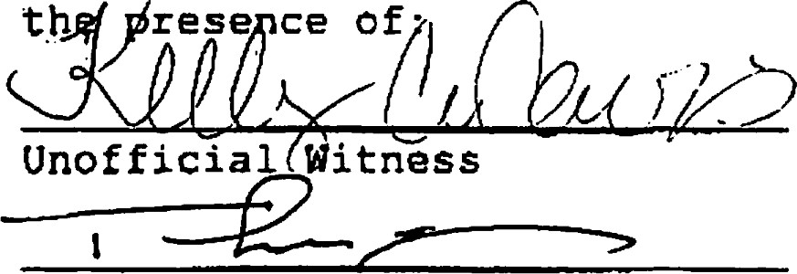
Signed, sealed and delivered in
Notary Public
County of Appointment:
Expiration of Commission:
[NOTARY SEAL]
3c: \reai. est\oeeanvai con\dec. tin
46
day of 1998 .
DECLARANT :
OCEAN WALK,
By: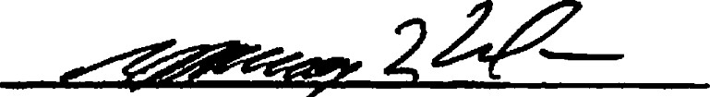
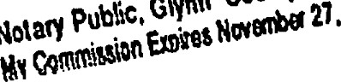
Its Managing M mber
Now}
Ggotqig

EXHIBIT "A" TO THE DECLARATION OF CONDOMINIUM FOR OCEAN WALK, A CONDOMINIUM
ALL THAT TRACT OF LAND on St. Simons Island in the 25th Georgia Militia District of Glynn County Georgia, described as follows:
BEGINNING at a point located on the southeast right-of-way line of Mallery Street (a 60 foot right-of-way at that point) which point is located South 78 degrees 34 minutes 00 seconds East 60.75 feet from the intersection of the northwest right-of-way line of Mallery Street with the north right-ofway line of Leake Street (50 foot right-of-way); running thence South 78 degrees 50 minutes 00 seconds East 477.88 feet to a point; thence South 74 degrees 14 minutes 00 seconds East 658.74 feet to a point on the northwest right-of-way line of Harlem Lane (50 foot right-of-way); thence along the northwest right-of-way line of Harlem Lane South 20 degees 03 minutes 59 seconds West 886.78 feet to a point; thence North 62 degrees 35 minutes 00 seconds West 619.97 feet to a point; thence North 27 degrees 21 minutes 00 seconds East 295.00 feet to a point; thence North 60 deyees 24 minutes 00 seconds West 573.00 feet to a point on the southeast right-of-way line of Mallery Sfreet (an 80 foot right-of-way at fflat point); thence along the southeast right-of-way line of Mallery Street North 22 degrees 41 minutes OO seconds East 296.93 feet to the PONT OF BEGNNING, containing 16.06 acres as shown on that certain as built survey of Windsong Apartments, prepared by Freeman & Vaughn Engineering, Inc., bearing the seal and certification of Michael A. Hussey, Georgia Registered Land Surveyor No. 2509, dated April 29, 1997, last updated and revised September 13, 1998.
EXHIBIT "B" •ro THE DECLARATION OF CONDOMNIUM FOR

OCEAN WALK, A CONDOMNIUM

PERMITTED EXCEPTIONS
- General and special taxes or assessments for 1998 and subsequent years, not yet due and payable.
- Easement from J. C. Strother Co. to Georgia Power Company, dated November 4, 1940, and recorded in Mortgage Book 47, Page 1 5, Glynn County, Georgia records.
- Rights of tenants in possession of individual apartment units, as tenants only.
- Rights of upper and lower riparian owners in and to the waters of rivers, creeks or branches crossing or adjoining the property, and the natural flow thereof, free from diminution or pollution.
- That As-Built survey for Windsong Apartnents, GM District 25, St. Simons Island, Glynn County, Georgia, known as 850 Mallery Street, dated April 29, 1997, last revised December 24, 1997 prepared by Michael A. Hussey, Georgia Registered Land Surveyor No. 2509, discloses the following:
  - Eight-inch clay sanitary sewer lines crossing the western boundary line of the land.
  - Elecå•ical lines crossing the western boundary line of the land and extending between buildings located on the land.
  - Telephone lines crossing the western boundary line ofthe land and extending between buildings located on the land.
  - Gas lines crossing the western boundary line of the land and extending between buildings located on the land.
Lights and sign encroach across the westem boundary line of the land.
Fire hydrant located on the western boundary line of the land.
  - Thirw foot building set-back line from the westem boundary line of the land, fifteen foot building set-back line for the northern and southern boundary lines of the land, and thirty foot building set-back line from the eastem boundary line of the land.
  - Fence encroaches 5.26 feet over the northern boundary line of the land.
Six foot chain link fence located along the perimeter of the land.
Existing lake located within the boundary lines of the land.
Fifteen inch RCP extends across the eastern boundary line of the land.
Miscellaneous utility facilities located within the boundary lines ofthe land, including CATV lines, transformer pads, gas meter with cut-off, sanitary sewer man holes, two-inch gate valve and back flow preventor, power meter, fire hydrants, grate inlets, fifteen inch RCP's, six inch clay and eight inch clay pipes, lights and dumpster pads.

EXHIBIT "C" TO DECLARATION OF CONDOvm^{s}11UM OF OCEAN WALK, A CONDOMINIUM

Description of Boundaries of Units
The vertical (lateral) boundaries of each unit located on the Propertyare the planes formed by the outer, exterior surfaces (facing away from such unit) of the wallboard comprising a part of the exterior walls enclosing such unit. Such vertical boundaries shall be deemed to include all doors, windows and screens serving such unit, and ail lath, wallboard, molding, tiles, wallpaper, paint, and any other materials constituting any part of the interior, finished surfaces of the walls enclosing any unit, irrespective of whether any of the same are in fact located within the vertical boundaries herein described.
The upper horizontal boundaries of all second floor units are the planes formed by the upper, exterior surfaces (facing away from such unit) of the wallboard or wood decking comprising a part of the ceilings enclosing such unit. The lower horizontal boundary of all second floor units is the lower, exterior surface of the floor enclosing such unit. The upper horizontal boundaries of all first floor units located on the Property are the planes formed by the upper, exterior surfaces of the ceilings enclosing such units. The lower horizontal boundaries of each first floor unit located on the Properw are the planes formed by the lower, exterior surfaces (facing toward such unit) of the floor of such unit. Such horizontal boundaries shall be deemed to include all wallboard, paint, tiles, finished flooring, and any other materials constituting any part of the finished surfaces of the floors and ceilings enclosing such unit, irrespective of whether any of the same are in fact locate within the horizontal boundaries herein described.
All of the vertical and horizontal boundaries herein described shall be extended to the intersections with each other.
All of the boundaries above described are shown and depicted on the Plans prepared by Ussery-Rule Architects, P.C., which Plans are more specifically identified in Section 5.01 of this Declaration.
Notwithstanding the description of the boundaries of the units set forth in this Exhibit "C", or the depiction of said units on the said Plans, there shall be deemed to be included within the boundaries on each unit all portions of the heating and air-conditioning systems (including furnaces, compressors, conduits, pipes, wires, ducts and the like) serving only that unit; and such portions of the heating and air-conditioning system shall be deemed to be contained within the boundaries of the unit, and shall fonn a part of the unit, exclusively served by the same, regardless of whether the same are located within or without the bouildaries of such unit described in this Exhibit "C" and depicted on the said Plans.
EXHIBIT "D' TO DECLARATION OF FOR

OCEAN WALK, A CONDOMNIUM

Description of Limited Common Elements
The Limited Common Elements which are located on the Property are as follows:
- All Balconies which are appurtenant to each Unit having a Balcony shall be a Limited Common Element assigned to the Unit having direct access thereto. All of the Balconies located on the Property are shou^{t}n and depicted on the Plans prepared by Ussery-Rule Architects, P.C., which Plans are more specifically identified in Section 5.01 of this Declaration.
- All Terraces which are appurtenant to each Unit having a Terrace shall be a Limited Common Element assigned to the Unit having direct access thereto. All of the Terraces on the Property are shown and depicted on the Plans prepared by Ussery-Rule Architects, P.C. which Plans are more specifically identified in Section 5.01 of this Declaration.
- All portions of the Common Elements on which there is located any portion of the heating and air-conditioning system exclusively serving a particular Unit or Units shall be a Limited Common Element assigned to the Unit or Units which is or are exclusively served by such heating and air-conditioning system.
EXEffBIT "E" To THE DECLARATION OF CONDOMNIIJM FOR OCEAN WALK, A CONDOMNIUM

ALLOCATION OF UNDIVIDED NTEREST
IN THE COMMON ELEMENTS, AND SHARES OF LIABILITY FOR COMMON EXPENSES
- The undivided interest in the Common Elements which are allocated to each Unit is as follows:
  - The following Units are assigned an undivided 0.337838 percent interest in the Common Elements: Units 1-16 in Building "A"; Units 1-8 in Building "C"; Units 1-16 in Building and Units 1-16 in Building "T".
  - The following Units are assigned an undivided 0.439189 percent interest in the Common Elements: Units 1-16 in Building "E"; Units 1-8 in Building "D"; Units 1-8 in Building "F"; Units 1-16 in Building "H"; Units 1-16 in Building "J"; Units 1-8 in Building "K"; Units 1-16 in Building "L"; Units 1-8 in Building "O"; Units 1-16 in Building "Q"; and Units 1-16 in Building
  - The following Units are assigned an undivided 0.506757 percent interest in the Common Elements: Units 1-8 in Building and Units 1-8 in Building
  - The following Units are assigned an undivided 0.523649 percent interest in the Common Elements: Units 1-6 in Building "B"; Units 1-6 in Building "G"; Units 1-8 in Building "M"; Units 1-6 in Building "N", and Units 1-6 in Building "U".
- The share of liability for Common Expenses allocated to each Unit is equal to the undivided interest in the Common Elements.

EXHIBIT "F" TO THE DECLARATION OF CONDOMINIUM FOR
OCEAN WALK, A CONDOMINIUM
BY-LAWS OF
OCEAN WALK CONDOMINIUM ASSOCIATION, INC.
ARTICLE 1
Name and Location
Section 1. Name. The name of the association is Ocean Walk Condominium Association, Inc , a Georgia nonprofit membership corporation, hereinafter referred to as the "Association. "
Section 2. Location. The principal office of the Association shall be located in Glynn County, Georgia. Meetings of members and directors may be held at such places within the Glynn County, Georgia as may be designated from time to time by the Board of
Directors .
ARTICLE 11
Definitions
Section 1. General. The terms used in these By-Laws, unless otherwise specified or unless the context otherwise requires, shall have the meanings specified in Official Code of Georgia Annotated Section 44-3-71 and the Declaration for Ocean Walk, A Condominium
(hereinafter called the "Declaration") . Statutory references shall be construed as meaning the referenced statute or portion thereof as the same may exist from time to time .
ARTICLE 111
Membership and Voting Rights
Section 1. Membership. Each unit owner shall automatically be a member of the Association, which membership shall continue during the period of ownership by such unit owner.
Section 2. Voting Rights. The Association shall have one class of voting membership which shall consist of all unit owners. Such owners shall be entitled to exercise voting rights as provided in the Georgia Condominium Act, the Declaration and as prescribed herein. The number of votes allocated to each unit is as set forth in the Declaration. When a unit is owned by other than one or more natural persons, the person entitled to cast the vote for such unit shall be designated by a certificate signed by the record owner of such unit and filed with the Secretary. Each such certificate shall be valid until revoked, superseded by a subsequent certificate or a change occurs in the ownership of such unit. When a unit is owned by more than one natural person, they may, without being required to do so, designate the person entitled to cast the vote for such unit as provided above. In the event they do not designate such a person, the following provisions shall apply:
- If only one is present at a meeting, the person present shall be counted for purposes of a quorum and may cast the vote for the unit, just as though he owned it individually, and without establishing the concurrence of the absent person or persons .
- If more than one of such owners, whether or not all
of them, are present at a meeting and concur, any one of the owners
may cast the vote for the owners.
- If more than one of such owners, whether or not all of them, are present at a meeting and are unable to concur in their decision upon any subject requiring a vote, they shall lose their right to vote on that subject at that meeting.
The votes of the unit owners shall be cast under such rules

and procedures as may be prescribed in the Declaration or in these Bylaws, as amended from time to time, or by law.
Section 3. Suspension of Voting Rights. During any period in
which a unit owner shall be in default in payment of any assessment, the voting rights of such unit owner shall be suspended
by the Board of Directors until such assessment has been paid. Such rights of a unit owner may also be suspended, for a period not to exceed thirty (30) days, for violation of any rules and regulations
established by the Board of Directors.
ARTICLE IV
Meetings of Unit Owners
Section 1. Annual Meetings. The first annual meeting of the unit owners shall be called by the President upon request of the
Declarant and shall be held within twelve (12) months following the incorporation of the Association. Each subsequent regular annual meeting of the owners shall be held on the same day of the same month of each year thereafter unless otherwise provided by the unit owners at any previous meeting. If the day for the annual meeting of the unit owners is a legal holiday, the meeting will be held on the first day following which is not a legal holiday.
Section 2. Special Meetings. Special meetings of the unit owners may be called at any time by the President or by the Board of Directors, or upon written request of the unit owners who are entitled to vote at least fifteen (15%) of the votes of the membership .
Section 3. Notice of Meetings. Written notice of each meeting of the unit owners shall be given by, or at the direction of, the Secretary or person authorized to call the meeting at least twentyone (21) days in advance of any annual or regularly scheduled meeting, and at least seven days in advance of any other meeting, stating the time, place and purpose of such meeting. Such notice shall be delivered personally or sent by United States mail, postage prepaid, to all unit owners of record at such address or addresses as any of them may have designated, or, if no other address has been so designated, at the address of their respective units. Such notice shall also be sent by United States mail, postage prepaid, to each institutional holder of a first mortgage on a unit having theretofore requested same in writing.
Section 4. Quorum. The presence at the meeting of unit owners and/or proxies entitled to cast more than one—third of the votes of the eligible owners shall constitute a quorum for any action except as otherwise expressly provided in the Georgia Condominium Act or in the Declaration. If, however, such quorum shall not be present or represented at any meeting, the unit owners and/or proxies entitled to cast a majority of the votes thereat shall have the power to adjourn the meeting from time to time, without notice other than announcement at the meeting, until a quorum as aforesaid shall be present or be represented.
Section 5. Proxies. Subject to the provisions of Article 3r Section 2, hereof, at all meetings of the unit owners, each unit owner may vote in person or by proxy. All proxies shall be in writing and filed with the Secretary. Each proxy shall be revocable, shall automatically cease upon conveyance by a unit owner of his unit and shall be effective only for the meeting specified therein and any adj ournment thereof
Section 6. Order of Business. The order of business at all annual meetings of the owners shall be as follows:
- Roll call.
- Proof of notice of meeting.
- Reading of minutes of preceding meeting.
- Reports of officers.
Report of Board of Directors.
- Reports of committees .
- Election of Directors.
- Unfinished business.
- New business.
Section 7. Decisions of Unit Owners . Unless otherwise expressly provided in the Georgia Condominium Act, the Declaration or these By—Laws, a majority of the votes cast on any particular issue shall be necessary to adopt decisions at any meeting of the unit owners. When the Georgia Condominium Act, the Declaration or these By—Laws require the approval or consent of all or a specified percentage of mortgagees and/or other lien holders, no decision or resolution duly adopted by the unit owners shall be effective or valid until such approval or consent shall be obtained. During such time as the Declarant has the right to control the Association pursuant to the provisions of Official Code of Georgia Annotated Section 44-3-101, no decision or resolution duly adopted by the unit owners shall be effective or valid until the Declarant 's approval or consent shall have been obtained.
Section 8. Conduct of Meetings. The President shall preside over all meetings of the unit owners and the Secretary shall keep the minutes of the meetings and record in a minute book all resolutions duly adopted as well as a record of all transactions occurring at such meetings. The latest edition of Roberts Rules of
Order shall govern the conduct of all meetings of the unit owners when not in conflict with the Georgia Condominium Act, the Declaration or these By-Laws.
Section 9. Action Taken Without a Meeting. In the discretion of the Board, any action that may be taken at any annual, regular, or special meeting of members may be taken without a meeting if the Association delivers a written consent form or ballot to every member entitled to vote on the matter.
- A written ballot shall: (1) set forth each proposed action; and (2) provide any opportunity to vote for or against each proposed action.
- Approval by written ballot pursuant hereto shall be valid only when the number of votes cast by ballot equals or exceeds the quorum required to be present at a meeting authorizing the action, and the number of approvals equals or exceeds the number of votes that would be required to approve the matter at a meeting at which the total number of votes cast was the same as the number of votes cast by ballot.
- All solicitations for votes by written ballot shall:
(1) Indicate the number of responses needed to meet the quorum requirements; (2) State the percentage of approvals necessary to approve each matter other than election of directers; and (3) Specify the time by which a ballot must be received by the
Association in order to be counted.
(d) A written ballot may not be revoked. The
Association shall maintain such ballots in its file for a period of at least three (3) years.
ARTICLE V
Board of Directors
Section 1. Number and Qualifications. Following expiration of the period of the Declarant's right to control the Association pursuant to the provisions of Official Code of Georgia Annotated Section 44-3-101, the Board of Directors of the Association shall be composed of five (5) persons. With the exception of those persons appointed as directors by the Declarant pursuant to the provisions of Official Code of Georgia Annotated Section 44—3—101, each such person shall be a member of the Association or the spouse of a member.
Section 2. Election and Term of Office. Upon the termination of the Declarant's right to control the Association pursuant to the provisions of Official Code of Georgia Annotated Section 44—3-101, the Declarant shall give at least seven (7) days written notice to each member of a special meeting of the members, to be held not more than thirty (30) days after the date of such termination, to elect a new board of directors. At the first election of directors of the Association following the expiration or termination of the Declarant's right to appoint directors hereunder, the directors shall be elected for staggered terms . At that meeting, two directors shall be elected for a term of one year and three directors shall be elected for a term of two years. Thereafter, all directors shall be elected for two (2) year terms. Except in the case of death, resignation or removal, each director elected by the members shall serve until the annual meeting at which his term expires and until his successor has been duly elected and qualified. Persons receiving the largest number of votes at any election of directors shall be elected whether or not such number constitutes a majority of the votes cast. Cumulative voting shall not be permitted.
Section 3. Removals; Vacancies. Following expiration of the period of the Declarant's right to control the Association pursuant to the provisions of Official Code of Georgia Annotated Section 44-3-101, any director may be removed from the Board of Directors with or without cause, by a majority vote of the unit owners theretofore entitled to elect such director. In the event of death or resignation of a director, his successor shall be selected by the remaining members of the board. In the event of removal of a director, his successor shall be elected by the unit owners theretofore entitled to elect such director. Any such successor shall serve for the unexpired term of his predecessor.
Section 4. Annual Organization Meeting. The first meeting of the Board of Directors following each annual meeting of the unit owners shall be held within ten (10) days thereafter, at such time and place as shall be fixed by the newly elected directors at such annual meeting, and no notice shall be necessary in order legally to constitute such meeting.
Section 5. Regular Meetings. Regular meetings of the Board of Directors may be held at such time and place as shall be determined from time to time by the Board of Directors. Notice of the time and place of regular meetings shall be given to every director by mail, facsimile or telephone at least three days prior to the date of such meeting.
Section 6. Special Meetings. Special meetings of the Board of Directors may be called by the President on two days notice to every director given by mail, facsimile or telephone and stating the time, place and purpose of the meeting. Special meetings shall be called by the President or Secretary in like manner and on like notice on the written request of directors entitled to cast at least three (3) votes at such meetings.
Section 7. Waiver of Notice; Action wi thout Meeting. Whenever notice of a meeting of the Board of Directors is required to be given under any provision of these By—Laws, a written waiver thereof, executed by a director before or after the meeting and filed with the Secretary, shall be deemed equivalent ..to notice to the director executing the same. Attendance at a meeting by the director shall constitute a waiver of notice of such meeting by the director if such director attends the meeting without protesting prior thereto or at the meeting's commencement the lack of notice to him. Neither the business to be transacted at, nor the purpose of, any meeting of the Board of Directors need be specified in any written waiver of notice. Any action required or permitted to be taken at any meeting of the Board of Directors may be taken without a meeting provided that a majority of the directors consent to the action In writing and the written consents are filed with the records of the proceedings of the Board of Directors. Such consents shall be treated for all purposes as a vote at a meeting.
Section 8. Voting; Quorum of the Board; Adjournment of Meetings. At all meetings of the Board of Directors, each director shall be entitled to cast one vote. The presence in person of directors representing at least two—thirds of the votes of the Board of Directors shall be a quorum at any Board of Directors meeting and a majority of the votes present and voting shall bind the Board of Directors and the Association as to any matter within the powers and duties of the Board of Directors.
Section 9. Powers and Duties. The Board of Directors shall have the powers and duties necessary for administration of the affairs of the Association and may do all such acts and things except as by law or the Declaration as may not be delegated to the Board of Directors by the unit owners. In exercising its powers and duties, the Board of Directors shall take as its standard the maintenance of the general character of Ocean Walk, A Condominium as a residential community of the first class in the quality of its maintenance, use and occupancy. Such powers and duties of the Board of Directors shall be exercised in accordance with and subject to all provisions of the Georgia Condominium Act, the Declaration and these By—Laws and shall include without limitation powers and duties to:
- Operate, care for, maintain, repair and replace the conunon elements and employ personnel necessary or desirable therefor.
- Determine common expenses of the Association.
- Collect assessments from the unit owners.
- Adopt and amend rules and regulations covering the details of the operation and use of the condominium.
- Open bank accounts on behalf of the Association and designate the signatories required therefor.
- Manage, control, lease as lessor, and otherwise deal with the common elements, including power to make shut-offs of common services and other interruptions of the normal functioning of the buildings to facilitate performance of any maintenance or repair work or the making of additions, alterations or improvements by the Association or the unit owners pursuant to provisions of the Declaration. The Board of Directors shall use reasonable efforts to disrupt the unit owners and occupants as little as possible in exercising such authority to effect shut—offs and other interruptions .
- Purchase, lease or otherwise acquire units offered for sale or lease or surrendered by their unit owners to the Association.
- Own, sell, lease, encumber, and otherwise deal in, but not vote with respect to, units owned by the Association. (i) Obtain and maintain insurance for the condominium pursuant to the provisions of the Declaration.
( 1) Make additions and improvements to and alterations of the common elements, and (2) make repairs to and restoration of the property after damage or destruction by fire or other casualty, or as a result of condemnation.
(k) Enforce by any legal or equitable remedies available all obligations of the unit owners or any of them to the Association. Such enforcement power shall include, without limitation, the power to levy, as assessments, fines against unit owners for default in the performance of said obligations in such amounts as from time to time the Board of Directors may deem proper in the circumstances, but not in excess of Twenty-rive $ (25.00) Dollars for any one violation, counting each day a violation continues after notice from the Board of Directors as a separate violation. If any owner fails to pay a fine within ten days after notification thereof, the Board of Directors may levy, assessments, additional fines to enforce payment of the initial fine.
(1) Appoint auditors of the Association.
- Employ a manager or managing agent and delegate thereto any duties of the Board of Directors under subparagraphs (a) , (c) , (i) and (o) of this Section 9.
- Conduct litigation and be subject to suit as to any cause of action involving the common elements or arising out of the enforcement of the provisions of the Georgia Condominium Act, the Declaration or these By—Laws.
- Make contracts in connection with the exercise of any of the powers and duties of the Board of Directors.
- Take all other actions the Board of Directors deems necessary or proper for the sound management of the condominium and fulfillment of the terms and provisions of the Georgia Condominium Act, the Declaration and these By-Laws . In the case of those powers and duties specified in the foregoing clauses (d) ,
(1) , and (m) , the Board of Directors need exercise the same only to the extent, if any, it deems necessary or desirable or is required to do so by vote of the unit owners. The Board of Directors shall not be obligated to take any action or perform any duty imposed upon it requiring an expenditure of funds unless in its opinion it shall have funds of the Association sufficient therefor.
ARTICLE VI

Officers
Section 1. Designation. The principal officers of the
Association shall be the President, the Vice President, the Secretary and the Treasurer, all of whom shall be elected by the
Board of Directors. One person may hold the office of Secretary and Treasurer simultaneously. The Board of Directors may appoint an assistant treasurer, an assistant secretary, and such other officers as in its judgment may be necessary. The Vice President may also hold the office of assistant secretary and perform the functions thereof in the absence of the Secretary. The President and Vice President shall be members of the Board of Directors. Any other officers may be, but shall not be required to be, members of the Board of Directors.
Section 2. Election of Officers. The officers of the Association shall be elected annually by the Board of Directors at the organization meeting of each new Board of Directors and shall hold office at the pleasure of the Board of Directors. Any vacancy in an office shall be filled by the Board of Directors at a regular meeting of the Board of Directors, or at any special meeting of the Board of Directors called for such purpose.
Section 3. Removal of Officers. Upon the affirmative vote of a majority of the votes of the Board of Directors, any officer may be removed, either with or without cause, and his successor may be elected at any regular meeting of the Board of Directors, or at any special meeting of the Board of Directors called for such purpose.
Section 4. Multiple Offices. The offices of Secretary and
Treasurer may be held by the same person. No person shall simultaneously hold more than one of any of the other offices except in the case of special offices created pursuant to Section I of this Article 6.
Section 5. President. The President shall be the chief executive of the Association. He shall preside at all meetings of
the unit owners and of the Board of Directors. He shall have all of the general powers and duties which are incident to the office of president of a corporation, including, , but not limited to, the power to appoint committees from among the unit owners from time to time as he may, in his sole discretion, deem appropriate to assist in the conduct of the affairs of the Association.
Section 6. Vice President. The Vice President shall take the place of the President and perform his duties whenever the
President shall be absent or unable to act . If neither the
President nor the Vice President is able to act, the Board of
Directors shall appoint some other member of the Board of Directors to act in the place of the President on an interim bayis. The Vice President shall also perform such other duties as shall, from time to time, be imposed upon him by the Board of Directors or by the
President .
Section 7. Secretary. The Secretary shall keep the minutes of all meetings of the unit owners and of the Board of Directors and shall have charge of such books and papers as the Board of Directors may direct. He shall, in general, perform all the duties incident to the office of secretary of a corporation and such other duties as shall, from time to time, be imposed upon him by the Board of Directors or by the President.
Section 8. Trea surer. The Treasurer shall have the responsibility for Association funds and securities and shall be responsible for keeping full and, accurate financial records and books of account showing all receipts and disbursements, and for the preparation of all required financial data; he shall be responsible for the deposit of all monies and other valuable effects in the name of the Association, in such depositories as may from time to time be designated by the Board of Directors, and he shall, in general, perform all the duties incident to the office of treasurer of a corporation and such other duties as shall, from time to time, be imposed upon him by the Board of Directors or by the President.
Section 9. Compensation. Unless otherwise expressly provided by the Board of Directors, no officer shall receive compensation from the Association for acting as such, but shall be entitled to reimbursement from the Association as a common expense for reasonable out—of—pocket disbursements made by him in the performance of his duties. No officer shall be obligated to make any such disbursements .
ARTICLE Vil
Officers and Directors: General Provisions
Section 1. Con tracts with Interested Parties. No contract or transaction between the Association and one or more of its officers or directors, or between the Association and any other entity in which one or more of the Association's officers or directors are officers, directors, partners or trustees, or have a financial interest, shall be void or voidable solely for this reason, or solely because the Association's officer or director is present at or participates in the meeting of the Board of Directors which authorizes the contract or transaction, or solely because his or their votes are counted for such purpose, if (a) the material facts as to his interest and as to the contract or transaction are disclosed or are known to the Board of Directors and the Board of Directors in good faith authorized the contract or transaction by a vote sufficient for such purpose without counting the vote or votes of the interested director or directors; or (b) the material facts as to his interest and as to the contract or transaction are disclosed or are known to the unit owners entitled to vote thereon, and the contract or transaction is specifically approved or ratified in good faith by vote of such unit owners; or (c) the contract or transaction is fair as to the Association as of the time it is authorized, approved or ratified by the Board of Directors or the unit owners. Interested directors may be counted in determining the presence of a quorum at a meeting of the Board of Directors which authorizes the contract or transaction.
Section 2. Indemnifica t ion. Pursuant to the provisions of Section 12.08 of the Declaration, the Association shall indemnity its officers and directors to the extent provided in and subject to the limitations of the Declaration.
ARTICLE Vill
Books and Records
Section 1. Books and Records. The Association shall keep such books and records as by law provided and shall make same available for inspection by any unit owner, any institutional holder of a first mortgage on a unit, and their respective agents and attorneys, for any proper purpose at any reasonable time. In addition, an annual report of the receipts and expenditures of the Association, based upon an audit made by an independent public accountant, shall be rendered by the Board of Directors to all unit owners, and to each institutional holder of a first mortgage on a unit having theretofore requested same in writing, within three months after the end of each fiscal year.
ARTICLE IX
Section 1. Amendments. These By-Laws may be amended only by the owners of the units to which two—thirds (2/3) of the votes in the Association cast their vote in person or by proxy at a meeting duly called for such purpose, written notice of which shall be delivered or sent to all unit owners not less than twenty-one (21) days in advance of the meeting stating the time, place and purpose of such meeting and the subject matter of the proposed amendment. Amendments to these By—Laws for the sole purpose of complying with the requirements of any governmental or quasi—governmental entity authorized to fund or guarantee mortgages on individual condominium units, as such requirements may exist from time to time, may be effected by an instrument duly executed by a majority of the directors of the Association. Each such amendment shall be effective when adopted or at such later date as may be specified therein.
ARTICLE X
Miscellaneous
Section 1. Conflicts. In the event of any conflict between the Declaration and these By-Laws, the Declaration shall control.
Section 2. Association Seal. The Association shall have a seal in circular form having within its circumference the Words: "Ocean
Walk Condominium Association, Inc. "
Section 3. Fiscal Yeam The fiscal year of the Association shall begin on the first day of January and end on the 31st day of December of every year, except that the first fiscal year shall begin on the date on which the Association was incorporated under the laws of the State of Georgia.
3c: \real. est \oceanwal. con \bylaws. con

Secretary of State | CONTROL NUMBER : 9834819
Corporations Division | EFFECTIVE DATE : 09/08/1998  COUNTY GLYNN
Suite 315, West Tower | REFERENCE 0048
2 Martin Luther King Jr. Dr. | PRINT DATE 09/21/1998 FORM NUMBER 311
Atlanta, Georgia 30334-1530
THOIAS J. LEE
300 STREET

SUITE 201
ST. SIMONS ISLAND, GA 31522

CERTIFICATE OF INCORPORATION
I, Lewis A. Massey, the Secretary of State and the Corporation Commissioner of the State of Georgia, do hereby certify under the seal of my office that
OCEAN WALR CONDOMINIt.na ASSOCIATION, INC.
A DOPESTIC NONPROFIT CORPORATION
has been duly incorporated under the laws of the State of Georgia on the effective date stated above by the filing of articles of incorporation in the office of the Secretary of State and by the paying of fees as provided by Title 14 of the Official Code of Georgia Annotated.
WITNESS my hand and official seal in the City of Atlanta and the State of Georgia on the date set forth above .
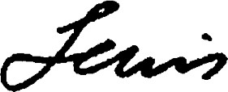
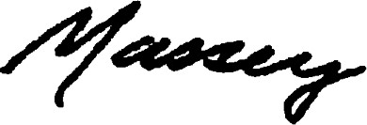
Lewis A. Massey
Secretary of State
Articles of Incorporation
ARTICLES O? INCORPORATION
OF
OCEAN WALK CONDOMINIUM ASSOCIATION, INC.
ARTICLE 1
The name of the corporation shall be:
OCEAN WALK CONDOMINIUM ASSOCIATION, INC.
ARTICLE 2
The corporation is organized pursuant to the provisions of the
Georgia Nonprofit Corporation Code.
ARTICLE 3
The corporation shall have perpetual duration.
ARI'IC%E 4
The corporation shall have no stock or stockholders; it is not organized and shall not operate for profit or pecuniary gain; and no part of the net earnings of the corporation shall inure to the benefit of any member, director, officer of any private individual except that, pursuant to proper authorization, reasonable compensation may be paid for services rendered to or for the corporation affecting one or more of its purposes. No substantial part of the act}, vities of the corporation shall be for carrying on of propaganda, or otherwise attempting to influence legislation, and the corporation shall not participate in or intervene in (including publishing or distributing statements) any political campaign on behalf of any candidate for public office.
ARTICLE 5
The purposes for which the corporation is organized are: to provide for the administration of a condominium to be known as Ocean Walk, A Condominium; to provide for the maintenance, repair, replacement and operation of portions of the conåominium; to promote the health, safety and welfare of the owners and occupants of the condominium; to exercise all rights and privileges and perform all duties and obligations of the corporation as set forth in the Georgia Condominium Act and in the Declaration for Ocean Walk, A Condominium to be recorded in the Office of the Clerk of the Superior Court of Glynn County, Georgia; and to perform such related functions as the board of directors of the corporation shall from time to time determine.
ARTICLE 6
In addition to, but not in limitation of, the general powers conferred by law, the corporation shall have the power to own, acquire, constr:uct, operate and maintain property, buildings, structures and 'other facilities incident thereto; . to supplement
municipal or governmental services; to fix and collect assessments to be levied against and with respect to the condominium units and the owners thereof which assessments shall be a lien and permanent charge on said units as well as the personal obl*gation of said owners; to enforce any and all covenants, restrictions and agreements applicable to the condominium; to buy, hold, lease, sell, rent, manage and otherwise deal in property of every kind and description, whether real or personal; to borrow money, issue promissory notes and other obligations and evidences of indebtedness and to secure the same by mortgage, deed, security deed, pledge or otherwise; and, insofar as permitted by law, to do any other thing that, in the opinion of the board of directors, will: promote, directly or indirectly, the health, safety, welfare, common benefit or enjoyment of the unit owners and occupants of said units; enhance, preserve or maintain property values within the condominium; enhance, preserve or maintain the appearance of the condominium and its surroundings; or be necessary, proper, useful or incidental to the carrying out of the functions for which the corporation is organized.
ARTICLE 7
The address of the initial registered office of the corporation shall be Thomas J. Lee at Plantation Village, Suite 201, 300 Main Street, St. Simons Island, Glynn County, Georgia 31522, and the name of its original agent at such address is Thomas
ARTICLE 8
The directors of the corporation shall be elected or appointed at the time and in the manner as provided in the By—Laws of the corporation as the same may from time to time be amended.
ARTICLE 9
The initial board of directors of the corporation shall number five (5) and shall be appointed by Ocean Walk, LLC, the Declaration, prior to the first conveyance of an Ocean Walk
Condominium Unit .
ARTICLE 10
The corporation shall have one class of members. Each owner of a condominium unit comprising a portion of Ocean Walk, A Condominium, shall automatically be a member of the corporation, which membership shall continue during the period of ownership by such unit owner . Pursuant to the provisions of the Georgia Condominium Act, the number of votes in the corporation allocated to each condominium unit is set forth in the Declaration for Ocean Walk, A Condominium. Said votes shall be cast under such rules and procedures as may be prescribed in the By-Laws of the corporation, as amended from! time to time, or by law.

Report ofExisting Facilities
October 1998 Page 5
FINAL NOTE:
This report does not constitute a detailed examination ofeach unit but rather a generalized overall look There may be instances that contradict some ofthe statements made here in or problems that were not observed.
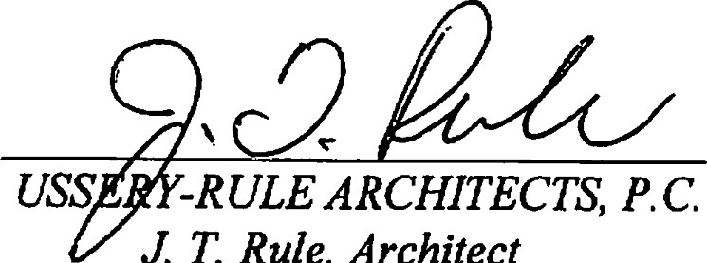
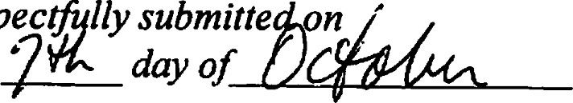
Respec this1998
T.
Rule,
Architect
Report ofExisting Facilities
October 1998
Page 4

5. EXTERIOR STAIRS AND BALCONIES
The exterior stairs are steelframe with wood 2 x 12 'sfor the stair treads. All the steelframework look to be in good condition and well painted.
A maintenance program ofpainting is critical to the longevity ofsteel in a salt atmosphere. All balconies arep.t. woodframe withp.t. 2 x 6 decking. With proper care the stairs and balconies should last indefinitely.

6. EXTERIOR DOORS AND WINDOWS
The windows are clear aluminum frame with single pane glass. They are the horizontal slider type with an aluminum frame screen on the outside. From the condition ofthe windowframe, it is expected that the aluminum is anodized in that it has resisted any oxidation. Overall, the windows are in good shape. The sealant around the exterior ofthe windows is new (1998).
The sliding glass doors are aluminum frame with single pane glass. The screen frames are aluminum and are mounted on the interior ofthe unit. The doors examined are relativelyfree ofcorrosion, indicating the aluminum is probably anodized The doors examined all operatefairly smoothly. The front doors and frames to the units are wood doors and appear in good shape. The windows and doors should last indefinitely with little maintenance.
7. INTERIOR FINISHES & CABINETS
The interior ofthe units examined had afew nail holes in the upsum board finishes on the walls. There were rough spots on the wall where the upsum board was not properly patched. The units are being repainted on the interior as they become available, and they are touching up these dings. The units that have been repainted look good.
The cabinets show some wear and need general alignment and tightening.
Counter tops are plastic laminate ofvarying ages. Currently some ofthe cabinets have been re-finished and re-worked and look good.
CODES AND REGULA TIONS
Contact with the local Building and Zoning Departments showed no outstanding notices ofuncured violations ofBuilding Code nor other County Regulations.
ARTICLE 11
These Articles of Incorporation may be amended as by law provided pursuant to resolution duly adopted by the board of directors and by at least two-thirds of the votes which members present in person or by proxy at a duly called meeting are entitled to cast; provided, however, that no members shall be entitled to vote on amendments to these Articles of Incorporation for the sole purpose of complying with the requirements of any governmental or quasigovernmental entity authorized to fund or guarantee mortgages on individual condominium units, as such requirements may exist from time to time, which amendments may be adopted only at a meeting of the board of directors upon receiving the vote of a majority of the directors then in office.
ARTICLE 12
The corporation may be dissolved as by law provided pursuant to resolution duly adopted by the board of directors and by at least four-fifths of the votes of the members of the corporation.
ARTICLE 13
The name• of the incorporator is Thomas J. Lee, whose address is Plantation Village Suite 201, 300 Main Street, St. Simons Island, Georgia 31522. The mailing address of the initial principal offib is Plantation Village, Suite 201, 300 Main Street,
5
St. Simons Island, Georgia 31522.
IN WITNESS WHEREOF, the incorporator has executed these
Articles of Incorporation.
Thomas J. Lee
Incorporator
CONSENT TO APPOINTMENT AS REGISTERED AGENT
TO: Lewis Massey
Secretary of State
Ex-Officio Corporation
Commissioner
State of Georgia
I, Thomas J. Lee, do hereby consent to serve as registered agent for the corporation Ocean Walk Condominium Association, Inc.
This 2nd day of September, 1998.
Thomas J. Lee
Address of Registered Agent:
300 Main Street, Suite 201
St. Simons Island, Georgia 31522 (912) 638-1180
3c: \real . est\ocenawal . con\areicles . inc

( b) YS8
861 W oz Il
6

I

REPORT OF EXISTING FACILITIES
Ocean Walk, A Condominium

St. Simons Island Glynn County Georgia
For:
Ocean Walk LLC
October 1998
Job #9826 USSER Y-RULE ARCHITECTS, P.C.
1804-A Frederica Rd.

St. Simons Island, GA 31522
2
GENERAL:
Representatives of USSERY-RULE ARCHITECTS, made inspections ofOcean Walk, formerly known asWindsong Apartments, in late August and early September 1998.
The buildings were constructed in the mid 1970's. Phase Iwas completed in 1973 and Phase Il completed in 1975. The buildings were re-modeled in early 1998 on the exterior, and are being remodeled on the interior as they are available between leases.
LWING UNITS:
The living units are slab on grade construction. The vertical structural elements are 2x4 wood frame walls and 2x4 partition walls. The secondfloorframing is 2x10 wood joists. The roof framing is wood truss construction.
All the buildings observed show no evidence ofany structural settling or shifting. The floor frames appear to be level and the walls plumb. With proper care and maintenance the living units should maintain their condition indefinitely.

swiMMING POOLS
The pool toward Mallory Street was re-conditioned in 1996. The cabanafor this pool was built in 1996. The other pool next to "W" Building was re-conditioned in 1990. The Cabana next to "W" Building was remodeled in early 1998. The pools are gunite construction and in good condition. They should last indefinitely with proper care and maintenance, with the occasional replacement offiltering and circulating equipment.
TENNIS COURTS
Tennis courts were redone in 1996 and appear in good condition. Normal maintenance intervals should keep the tennis courts in good condition.

MAINTENANCE BUILDING
This building is woodframe on a concrete slab and is in good condition. It was constructed in 1996. With normal maintenance it should last indefinitely.
3
LIVING UNITS
MAJOR BUILDING COMPONENTS

1. ELECTRICAL SYSTEMS
The facility is served by an underground primary distribution system that serves pad mounted transformers. Services at each building were arranged with grouped meters. The service lateral conductorsfrom the transformers are
"tapped' in the meter boxes and each unit 's service is run to their respective panel. Service conductors are aluminum.
Depending on size, each unit contains a 125 amp to 200 amp, 120/240v, 1 phase (loadcenter) panel with main breaker and individual branch breakerfor the various loads. Panels appear in good shape with little or no changes since the original installation. With normal maintenance these systems should last indefinitely.
- HEATING VENTILATION AND AIR CONDITIONING:
The units are heated and cooled by split-system air conditioning units with electric resistance heat. Some ofthe units are fairly new and some were somewhat older. They have been replaced when necessary. The duct systems appeared to be adequate. The registers and grilles were generally in good condition. No representation is made in regards to the useful life ofthis equipment.
- ROOF
There are two types ofroofing used on the units. The flat areas have a built-up bituminous roof The sloping roofs have what appears to be a Class A Fiber Glass Asphalt RoofShingle. Flat roofs were redone in 1990 and asphalt shingles were redone in 1998. The roofs appear to have been properly installed. The singles have a 20-year warranty. No representation is made in regards to the useful life ofthe flat roof

4. EXTERIOR slDING
New vinyl siding was put on the units in 1998. All siding observed appears to be in good condition. The joints have been caulked and are holding up well. With proper maintenance this siding should lastfor many years.

Unit No. Building
OCEAN WALK, A
NFORMATION, DOCUMENTS AND RECEIPT
ITEM NVhOER
DOES NOT EXIST
1. A typical Floor Plan for the Unit No. Attached in Building
2. | Copy of Declaraüon of Condominium for Ocean Walk, A Condominiumm, which includes a copy of the Bylaws for Ocean Walk Condominium Association, Inc. | Attached
3. | Copy of the Articles of Incorporation | Attached
4. | Estimated Operating Budget for the initial year of operation for Ocean Walk, A Condominium. | Attached
5. | Copy of each management, maintenance and other contact for the management and operation of the Ocean Walk Condominium Association, Inc., having a tenn in excess of one year. | Does Not Exist
6. | Declarant's Statement pertaining to Conversion Condominium. Statement that no representations are made in regards to the expected useful life of certain items. | Attached
7. | The Report of Exisüng Facilities prepared | Attached
by Ussery-Rule Architects, P.C. (the "UsseryRule Report"), describing the present condition of all structural components and mechanical and electrical systems, excluding fixtures and appliances within the units, material to the use and enjoyment of the Unit.
1

ITEM NUMBER DESCRæTION
DOES NOT EXIST
- A list, if any, of outstanding notice of Does Not Exist uncured violations of the Glynn County Building Code or other applicable building regulations together with the estimated cost of curing those violations.
- Statement setting forth the extent of and Does Not Exist conditions or limitations applicable to Declarant's commitnent to build or submit residential Imits, additional recreational or other facilities, or additional property to Ocean Walk, A Condominium. There is no commiünent to build or submit additional residential units, additional recreational or other facilities, or additional property to Ocean Walk, A Condominium,
- Any Ground Lease or Lease of any Recreational Does Not Exist
Facilities (that will be used only by Unit Owners).

The undersigned hereby expressly acknowledges that copies of the foregoing documents were actually delivered to and received by the undersigned on the day of1998.
So acknowledged this day of1998.
Address:

2
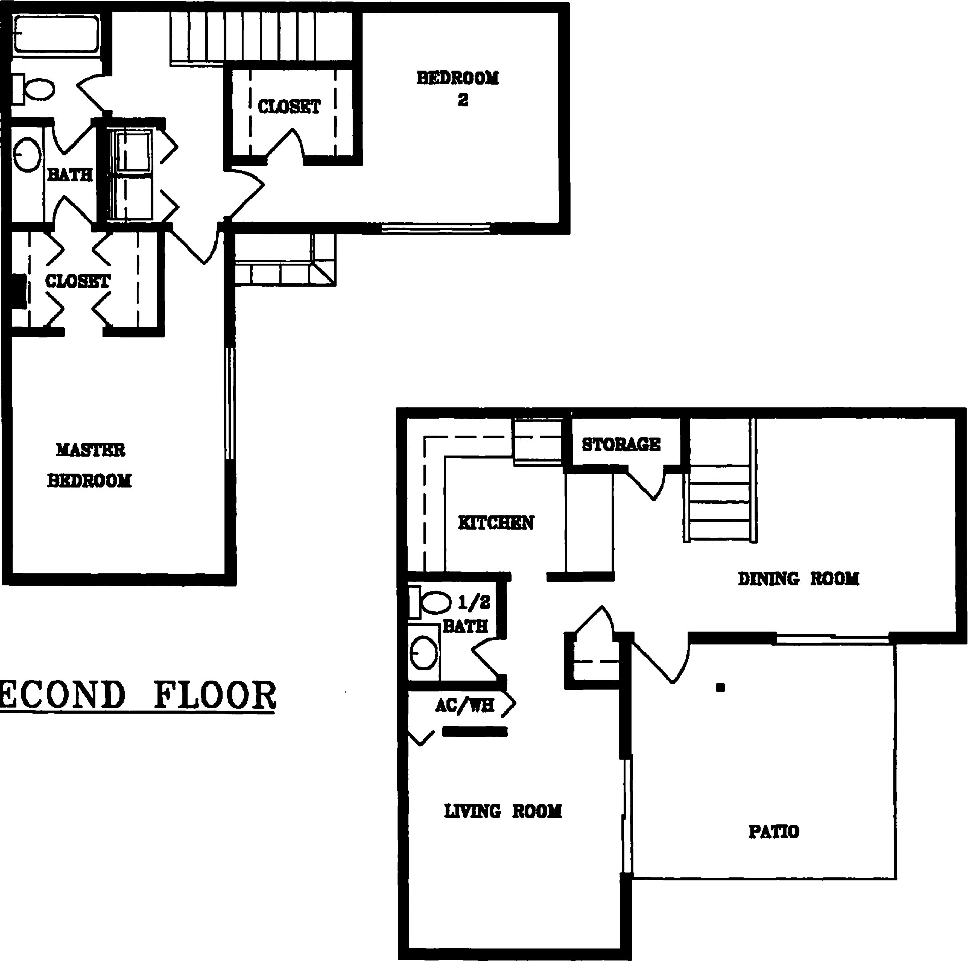
SECOND

FIRST FLOOR
10/7/98

OCEAN WALK, A CONDOMINIUM
2 BEDROOM, 1 1/2 BATH TOWNHOUSE UNIT
BUILDINGS: UNITS: 1 THRU 8
850 MALLORY STREET, SAINT SIMONS ISLAND, GEORGIA
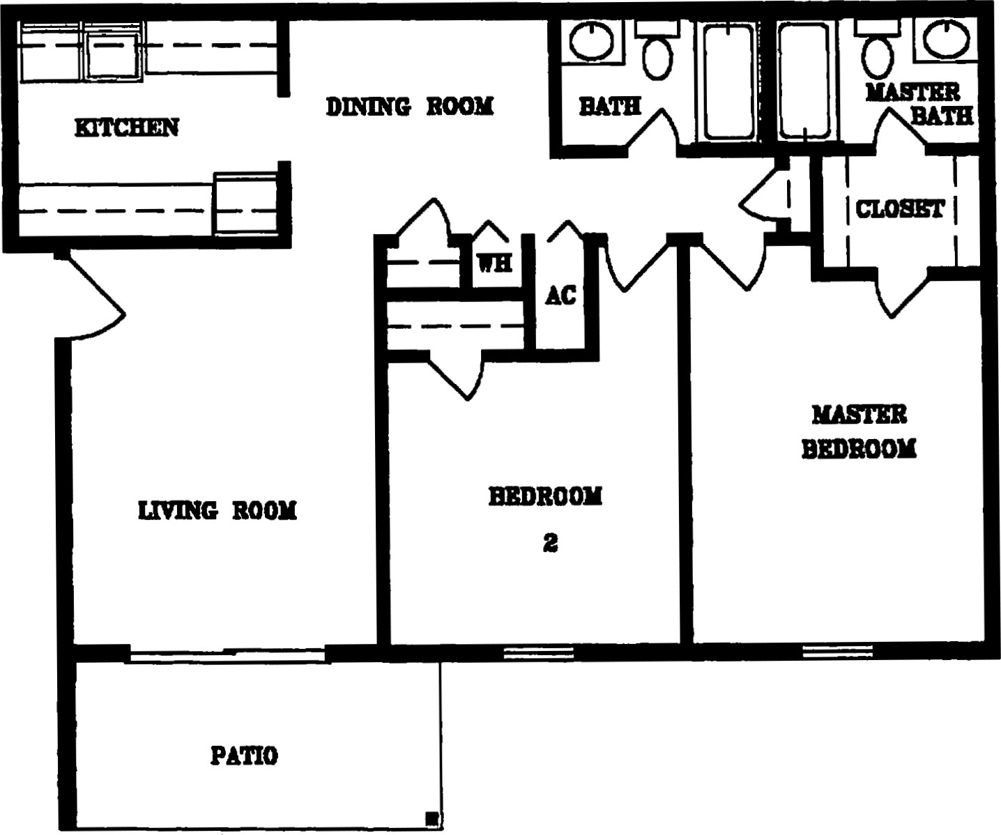
10/7/98

OCEAN WALK, A CONDOMINIUM
2 BEDROOM, 2 BATH GARDEN HOME UNIT
BUILDINGS: UNITS: 1 THRU 16
BUILDINGS: D UNITS: 1 THRU 8
850 MALLORY STREET, SAINT SIMONS ISLAND, GEORGIA

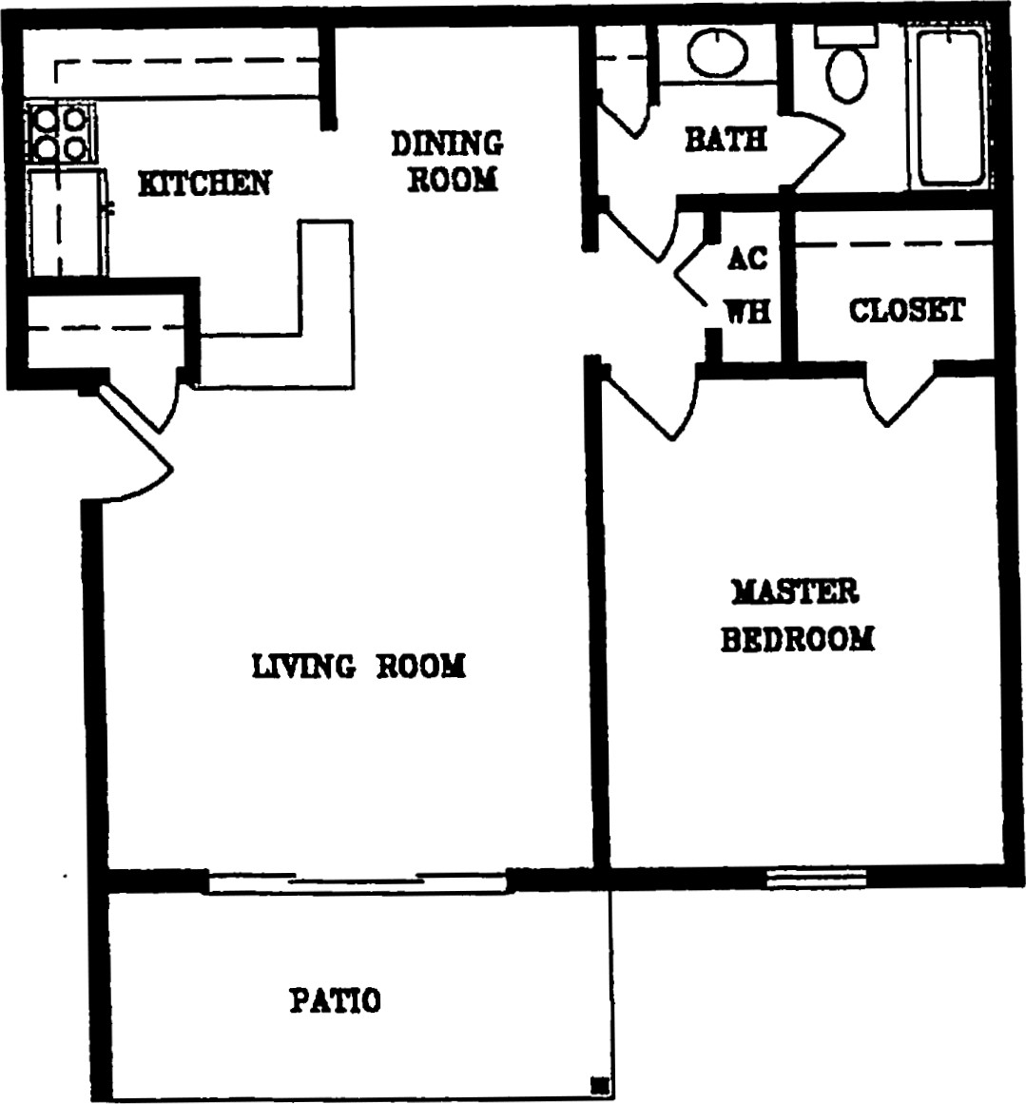
9/22/98
16'
OCEAN WALK, A CONDOMINIUM
1 BEDROOM, 1 BATH GARDEN HOME UNIT
BUILDINGS: UNITS: 1 THRU 16
BUILDINGS: C UNITS: 1 THRU 8
850 MALORY STREET, SAINT SIMONS ISLAND, GEORGIA
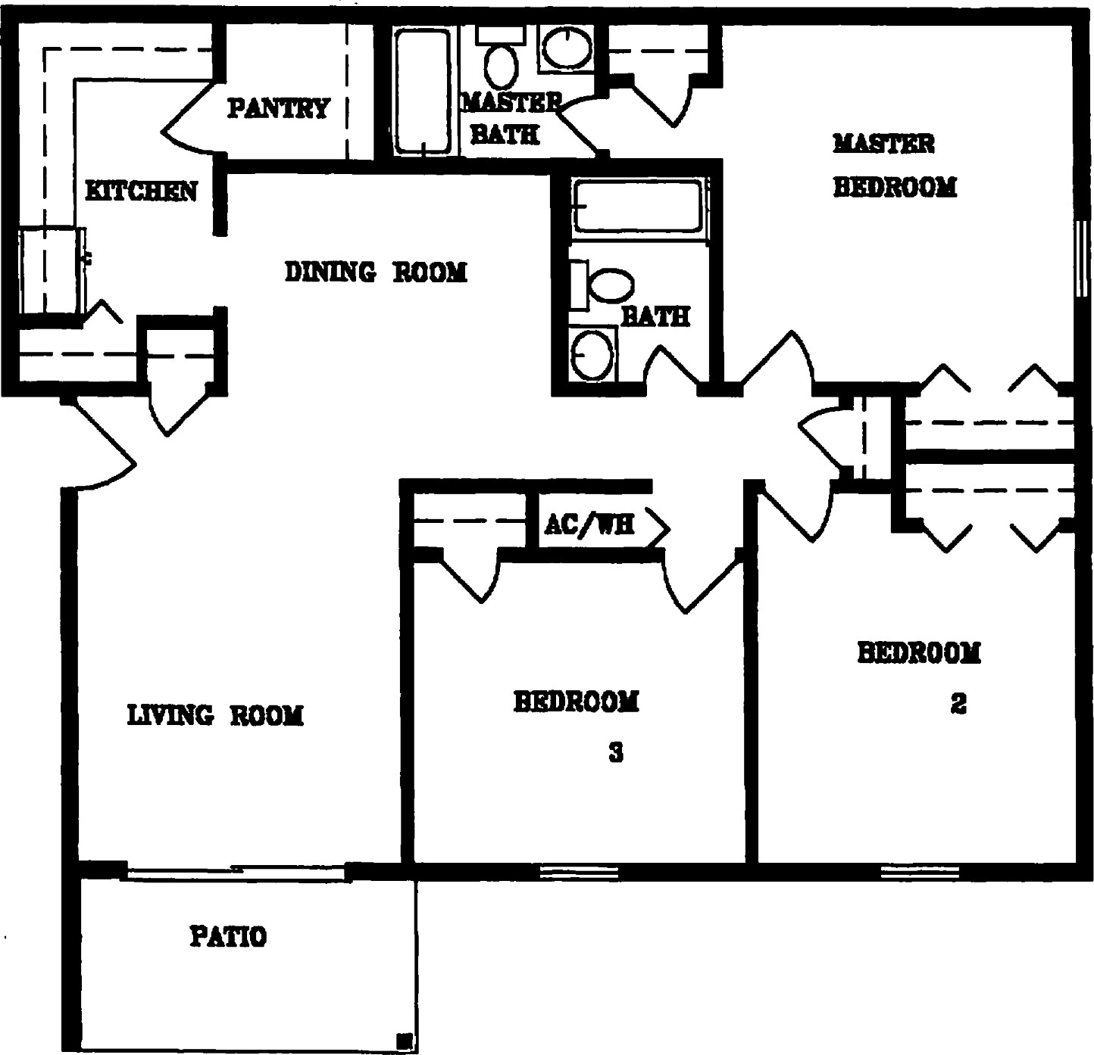
10/7/98

OCEAN WALK, A CONDOMINIUM
3 BEDROOM, 2 BATH GARDEN HOME UNIT
BUILDINGS: UNITS: 1 THRU 8
850 MALLORY STREET, SAINT SIMONS ISLAND, GEORGIA
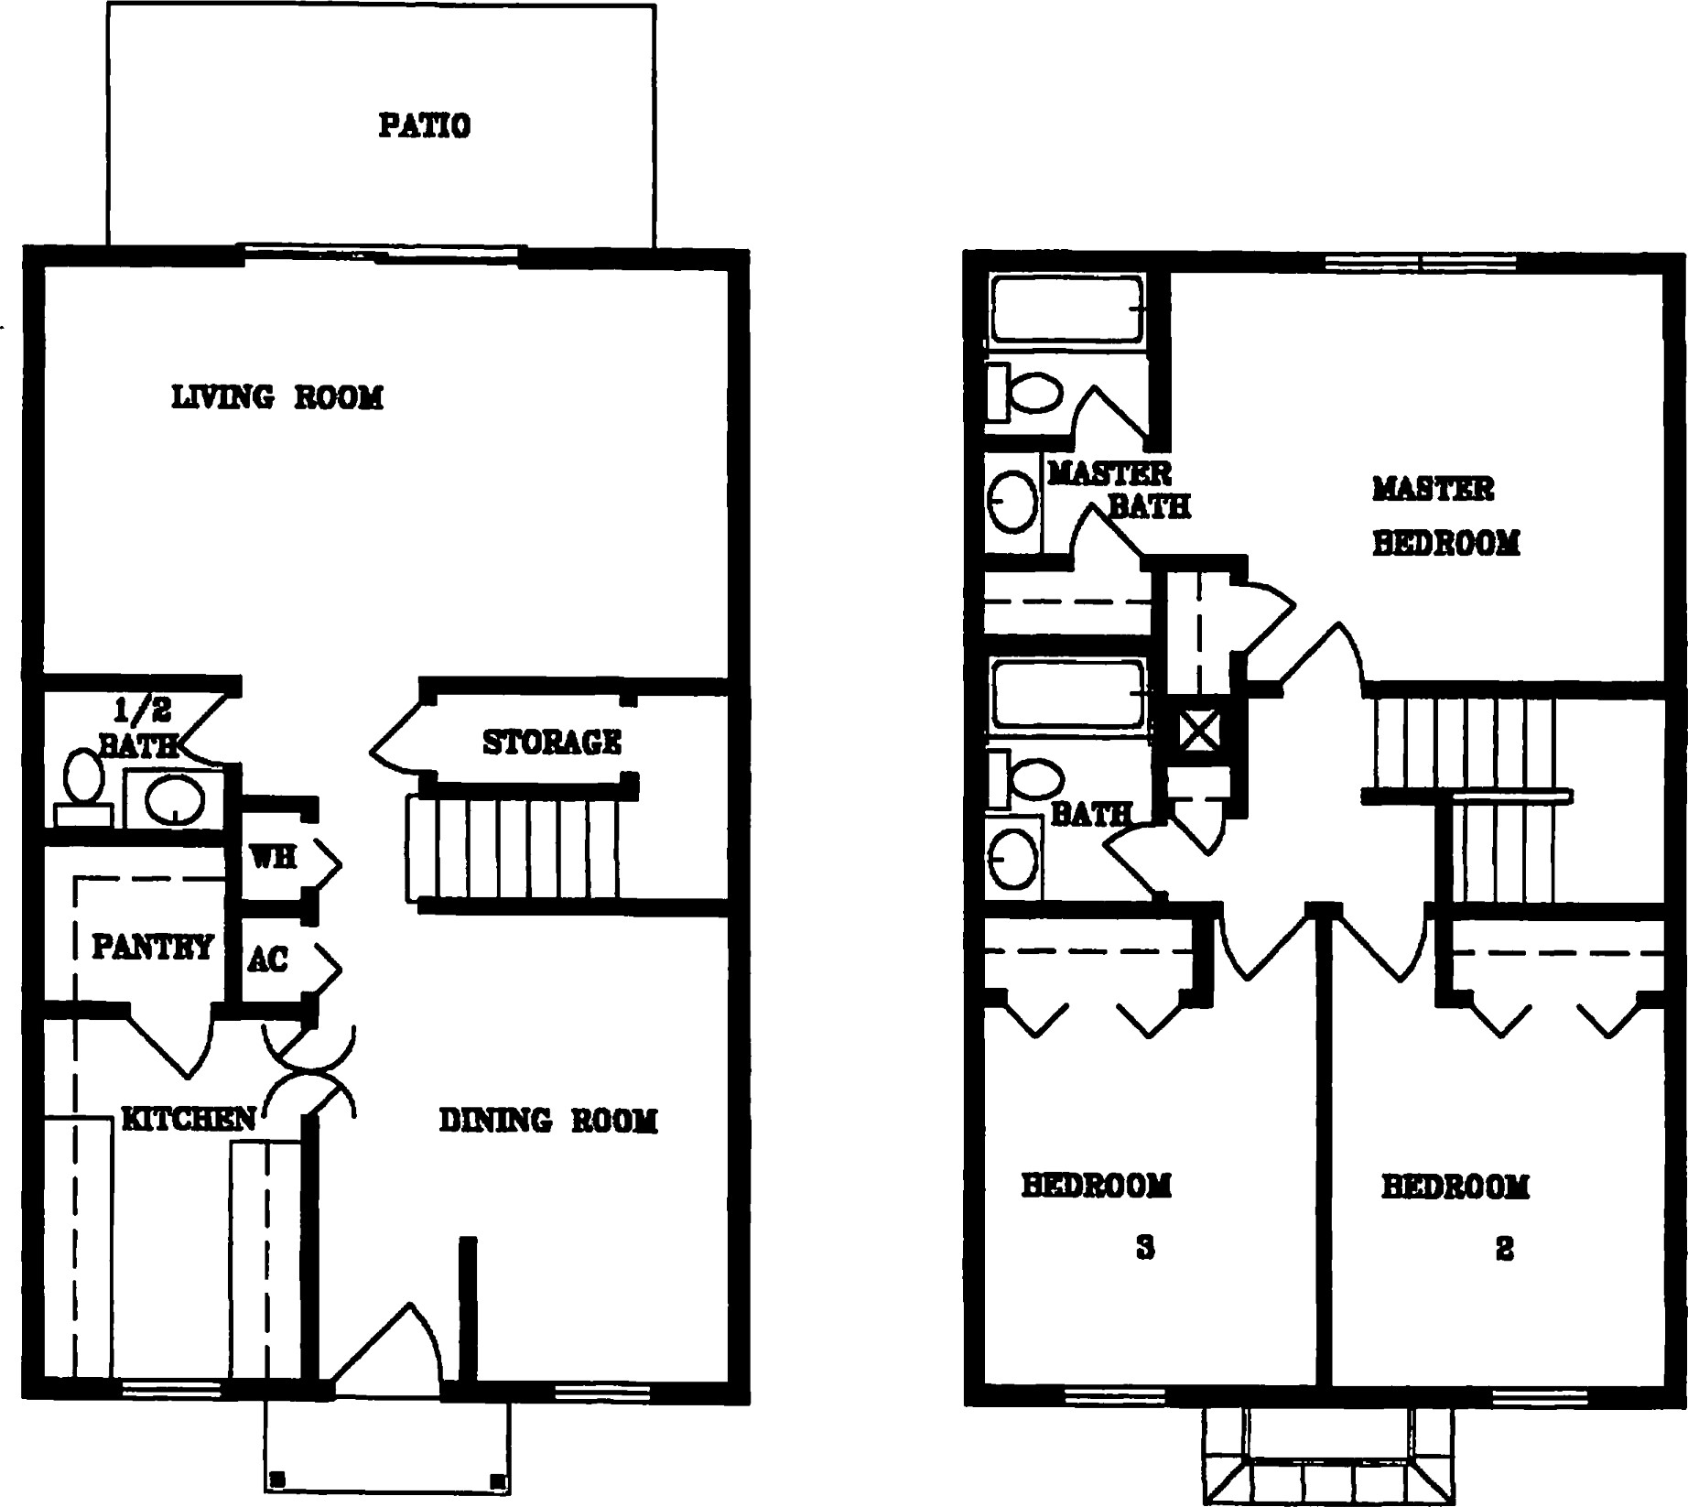

FIRST FLOOR SECOND FLOOR
16'
10/7/98

OCEAN WALK, A CONDOMINIUM
3 BEDROOM, 2 1/2 BATH TOWNHOUSE UNIT
BUILDINGS: UNITS: 1 THRU 6
BUILDINGS: M UNITS: 1 THRU 8
850 MALLORY STREET, SAINT SIMONS ISLAND, GEORGIA
Unit No. , Building
OCEAN WALK, A CONDOMNIUM
NFORMATION, CONDOMNIUM DOCUMENTS AND RECEIPT

DOES NOT EXIST
1. A typical Floor Plan for the Unit No. Attached in Building
2. | Copy of Declaration of Condominium for Ocean Walk, A Condominiumm, which includes a copy of the Bylaws for Ocean Walk Condominium Association, Inc. | Attached
3. | Copy of the Articles of Incorporation | Attached
4. | Estimated Operating Budget for the initial year of operation for Ocean Walk, A Condominium. | Attached
5. | Copy of each management, maintenance and other contract for the management and operation of the Ocean Walk Condominium Association, Inc., having a term in excess of one year. | Does Not Exist
6. | Declarant's Statement pertaining to Conversion Condominium. Statement that no representations are made in regards to the expected useful life of certain items. | Attached
 | The Report of Existing Facilities prepared by Ussery-Rule Architects, P.C. (the "UsseryRule Report"), describing the present condition of all structural components and mechanical and electical systems, excluding fixtures and appliances within the units, material to the use and enjoyment of the Unit. | Attached
1

c ( ( C c c c c c c c c c c c

ESTIMATD OPERATING BUDGrr
 | 100 |  |  |  |  | 100 |  |  | 100 | 100 | 100 | 1,200  3,mo  3,000  3 em
1.250  3750 | 1,250  3750 | 1.250  3750 | 1,250  3.750 | 1,250 | 1.250 | 1,30  2500 | 1.250 | 1,250 |  | 1.250 2500 | 1.250 2500 | 11400  15,000  30000
3000 | 3000 |  | 3000 | 3000 | 3.750 | 3,750 | 3.750 | 3.750 | 3,750 | 3.74 | 3,750 | 45,000
General & Emln%atve
MEüsIng & (Sgnage)
Service
Supplies
Accounürw & Profesional Foes
Toäf Genera! & Admtnistatw
Paw•oll
Manager (incl. benef&)
Porter (incl. bene&) Payroll
Management Fee 3000 3000 3000 3000 3000 36000
Maintenance S.l*ies
Appliance Supplies
HVAC Supp4iæ Untforms
GOY CaNGaslTruck
Oe•an Walk Condomintum Acocwon, Inc. Twelve Mont Operdng Budget
January | February | April | June | July | August | Oeober | Nm•ember | December
Toäl Malntenance
Contact SeMces
Pool Service | 1.000 | 1.000 | 1.000 | 1,000 | 1,000 | 1,000 | 1.000 | 1,000 | 1,000 | l.mo | 1.000 | 1.000 | 12000
Landscape SeMees  Seasonal CobrPinesåaw | 4,000 | 4.000 | 4.000 | 4.000 2600 | 4,000 | 4.000 | 4.mo | 4,000 | 4,000 | 4,000  2500 | 4.000 | 4.000 | 48,000  5100
trrigaüon  Janibrial SeMce (CtuM-aundry)  Pagers Termite Bond  Pest Contol  Trash Removal - Compa&r Lease  Trash - Montlfy %rvicø  Tout Coüact Services | 100  3,600  10.325 |  | 100  6.725 | 9.325 | 100 |  |  | 100 | 100 |  | 100 | 100 | 2400  4600 4.800 aow 6000
2000 2000  700  3.500 3.500  6.200 6.200 | 2000  3.500  6.200 | 2000  3.500 | 6.725 amo  3.500 | 6,73  2000  3.500 | 2000  3500 | 2.000  3.500 | 6.725  2000  3.500 | 2000  700  3.500 | 6,725  2000  3500 | 2,mo  700  3,500 | 89,400  24,000  4400  42.000
Assumes allocated uniE |  | 6.200 | 6.mo | 6.200 | emo | 6.200 | 6.200 | amo | 8.200 | 6.200 | 74.400
5.000 |  | 5,000
975 28375 | 26375 | 975 | 5,000 | 5.000  26375 | 5,000 | 5000 | 5,000 |  |  | 5,000 | 60,000
Utfiies
ElecüiciV
Gas
t.Æ&s
Real Esh Tams - Clubhouse
Insurance
TÜI E)oenses (before26375 26 375 28875 2637
Reserves
5.000
Reservæ are on an annual basis only 20,000
Estimabd ergs Abeation
Number of Monmly Fee Montity of Fee by Fee per
unit Typæ.• | uni& Per Untt Fees Unit Type Unt
1 bdm 1 ba | 100 5.600 IQ92% 0.337838%
2 bdrm 1.5 | 24 130 3,120 10.54% 0.43918%
2 bdrm 2 ba | 104 130 13,520 45.68% 0.439189%
3 bdm 2 ba | 16 150 2400 8.11% 0.506757%
3 bdm 2.5 barrwm | 4 960 16.76% 0.523649%  29,600 100.0%  12 Montts  355 200
PooY Ctubhousenennis Cout&
5,000

DECLARANT'S STATEMENT
PERTANING TO A CONVERSION CONDOvm1UM

AS REQUIRED BY SECTION 44-3-111 (b) (10) OF THE GEORGIA CONDOMNIUM ACT
- Declarant adopts as its statement required by Section 44-3-1 Il (b) (10) (A) O.C.G.A.
the "Report on Existing prepared by Ussery/Rule Architects, P.C., signed on October 7, 1998, a copy of which is attached hereto.
- Declarant makes no representations as to the expected useful life of each item reported on as provided in subparagraph A above.
c. To the best knowledge and belief of the Declarant, there are no outstanding notices of any uncured violations of building code or other county municipal regulations pertaining to the property.

